

User Manual
Recruitment Module
www.flowhcm.com



Table of Contents
Job Request 4
View Report 8
Job Post 9
Job Portal 13
Candidate Portal 15
View Report 25
Job Candidate 26
Upload Excel 31
Process Resume 32
Screening 33
CV Parsing 34
Apply Shortlisting Score 35
List for Test 37
Manager Shortlisting 38
Schedule Interview 39
Interview (1st, 2nd, 3rd ....) 40
Hiring Approval 41
Offer 42
Recruit 43
Reject 44
Dropout 45
Additional Features 46
Shortlist 51
Schedule Interview 52
Evaluation 53
Hiring Approvals 54
Recruitment Approvals 55
Recruitment Settings 56
Interview Template 57
Pipeline Template 58
Job Opening Field 60
Skill Set 63
Questionnaire Category 64
Recruitment Designation 65
Candidate Portal Settings 66
Candidate Portal Logs 67
General Recruitment Setting 68
Logo 68
Banner 69
Agreement Note 69

Job Request

- Click on Recruitment on the top navigation bar
- You can see the Job Request form
- To add Job request, click on Apply for Job Request
- Select the required data from dropdowns for the Job
- Select skill set required and No. of positions
- Job can be assigned to any specific employee for screening from Assign to Employee dropdown
- Enter required Candidate Salary and Age range
- A target joining date of candidate can be selected for the recruiter to be notified
- Attachment feature is also available
- Enter the required Job Experience, Description and Qualification of candidate
- Click on submit button to raise a requisition
- Request can be seen in grid along with some Action button features

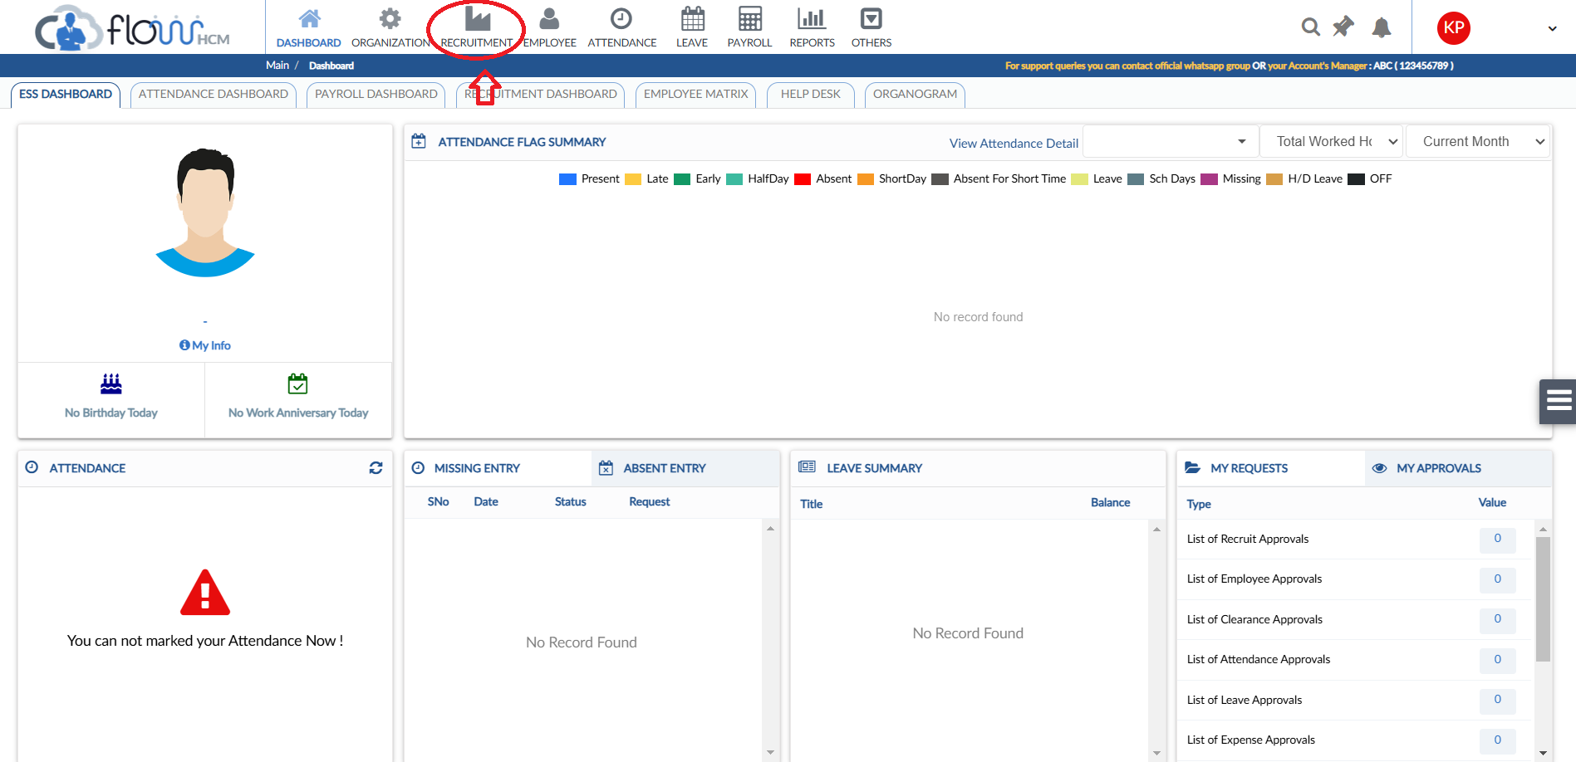
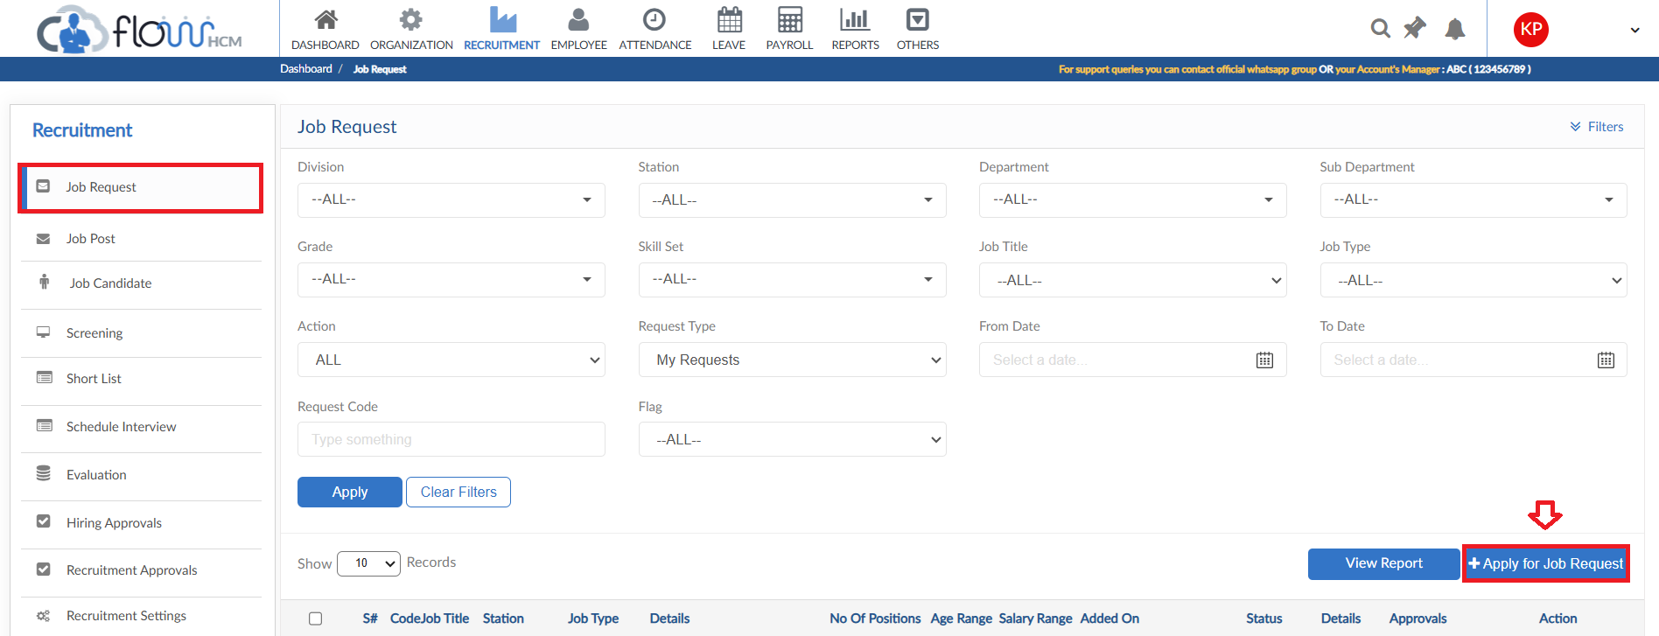
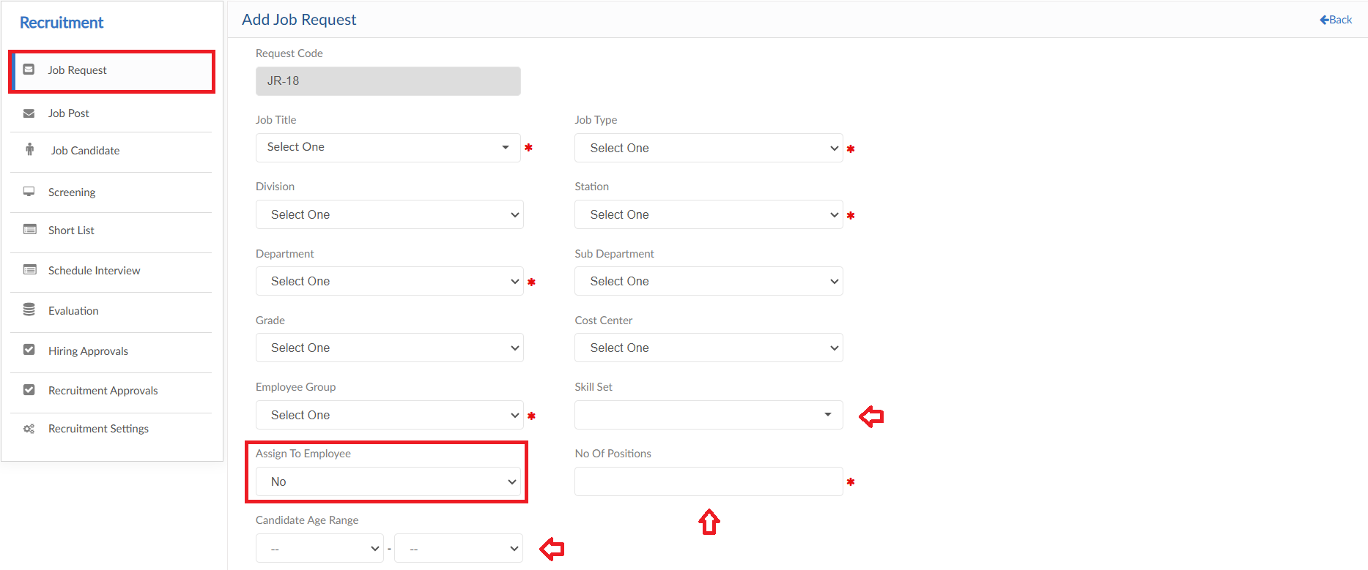
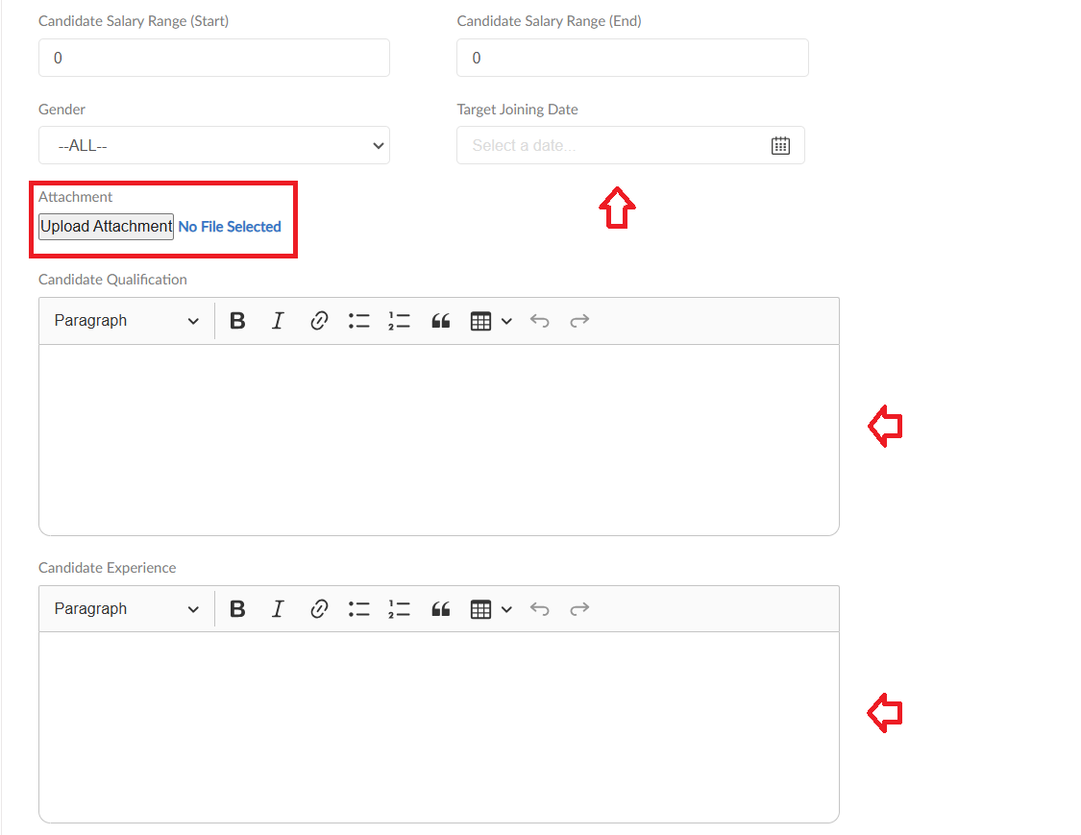

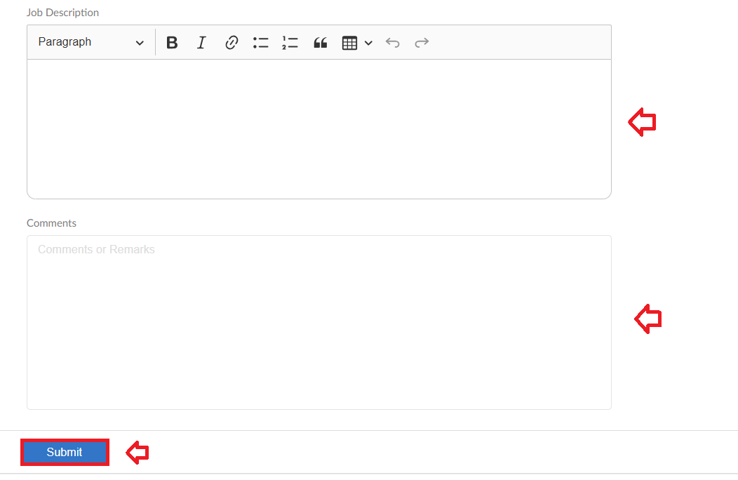
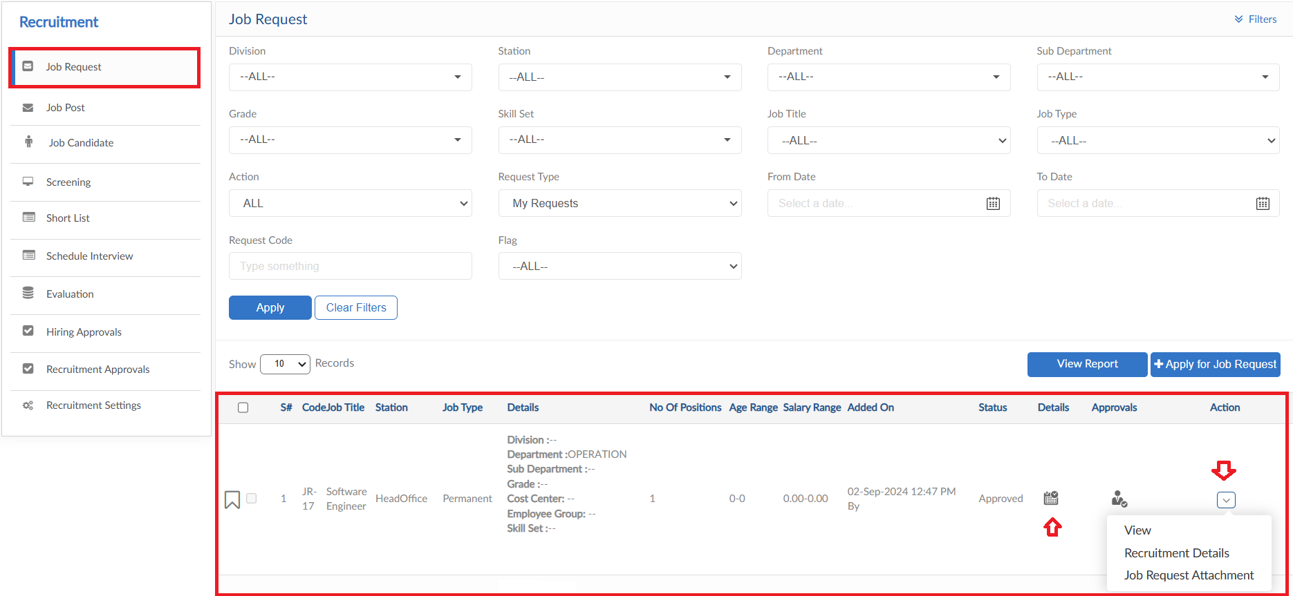

View Report
- To view the data of grid in Job Request form click on view report
- Job Request Report will pop up on screen

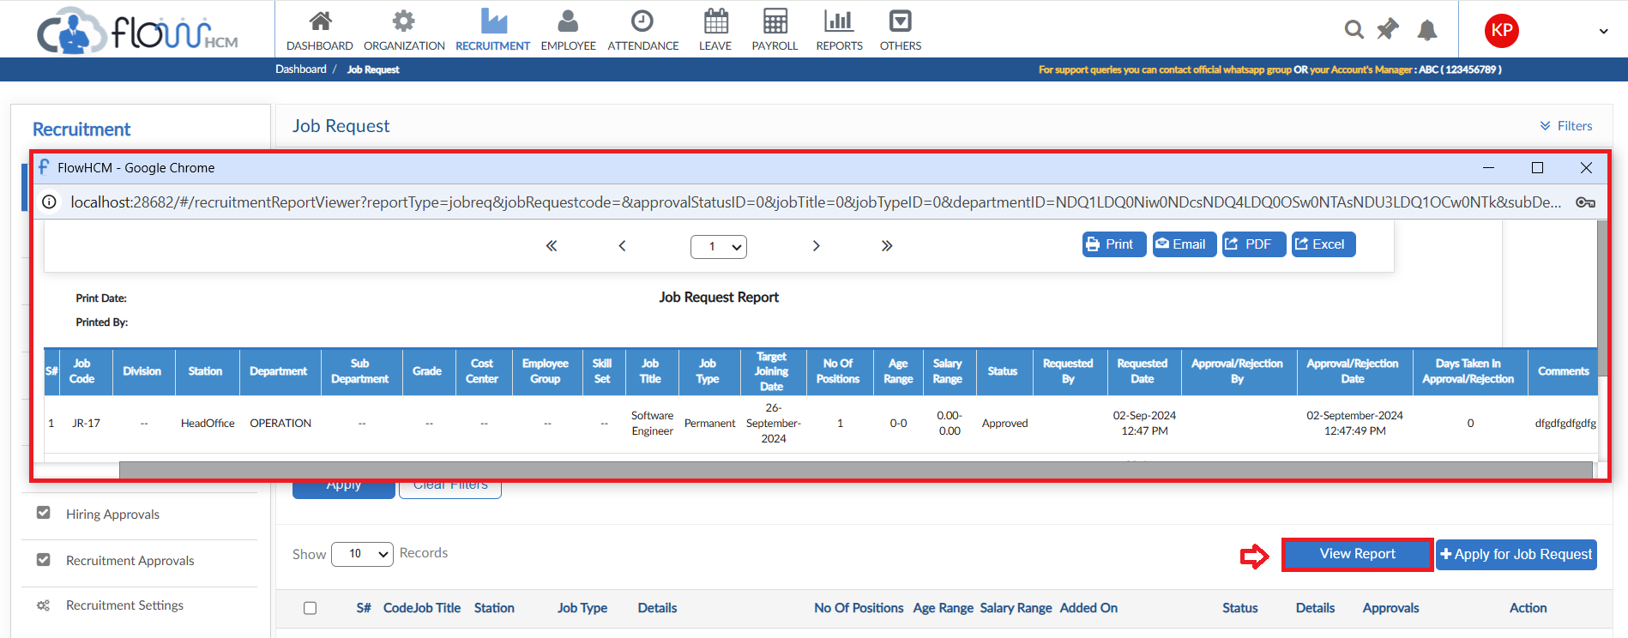

Job Post

- To add a Job Post, click on Add Job Post
- Select Job Opening Field Template and Pipeline from dropdowns
- User can either use the Job request data that will fill all the fields automatically else apply the same process as in Job Request fill all fields manually
- Enter a closing date of applying for the Job Post
- There is a feature of Job Portal in Recruitment Module, the Job will be published on the portal and candidate can apply online. If required select YES in Publish on Portal dropdown
- The Job Portal allows (check basis) candidate to create an account for application tracking and dashboard - - Candidate Portal
- Then click on submit to raise a requisition
- The system will then generate a link and QR code that can be posted on social platforms for candidates to apply online
- Request can be seen in grid along with some Action button features

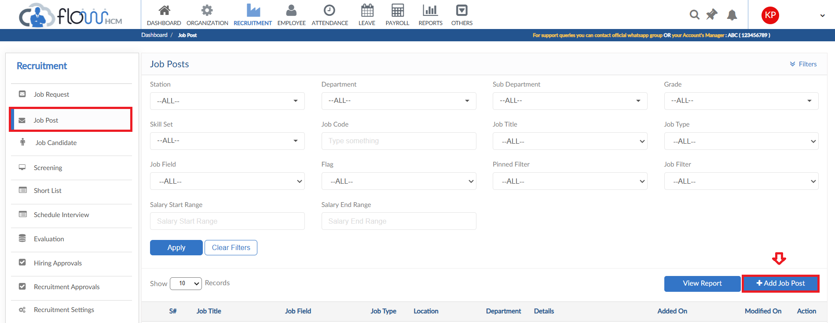
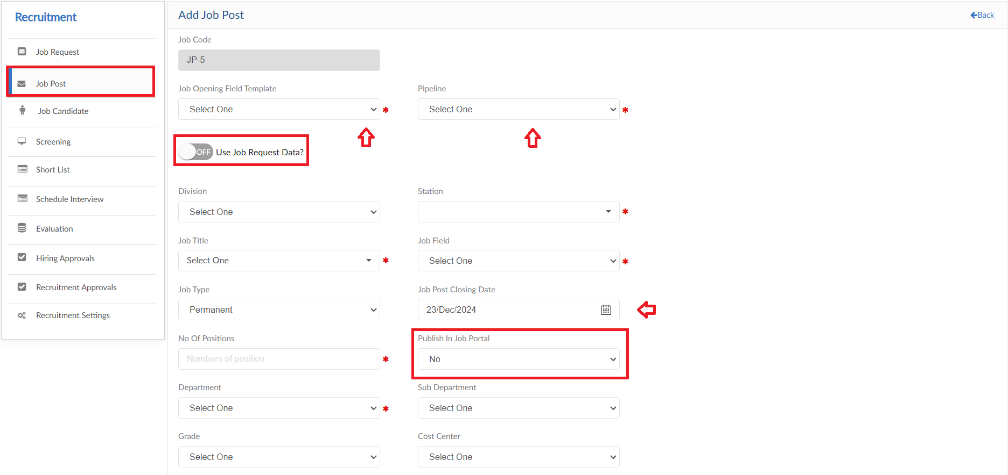
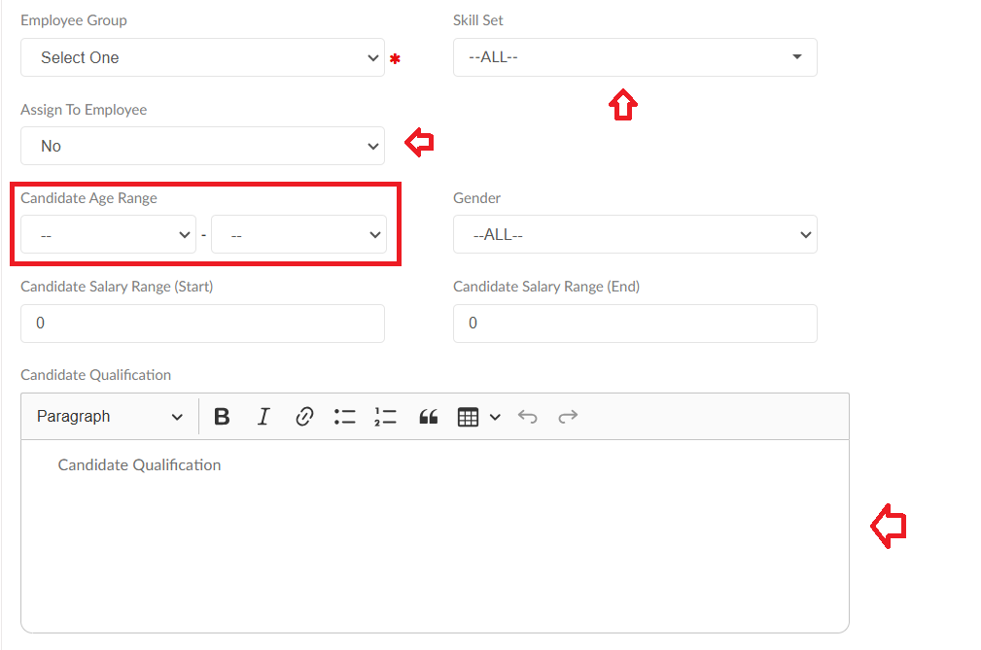
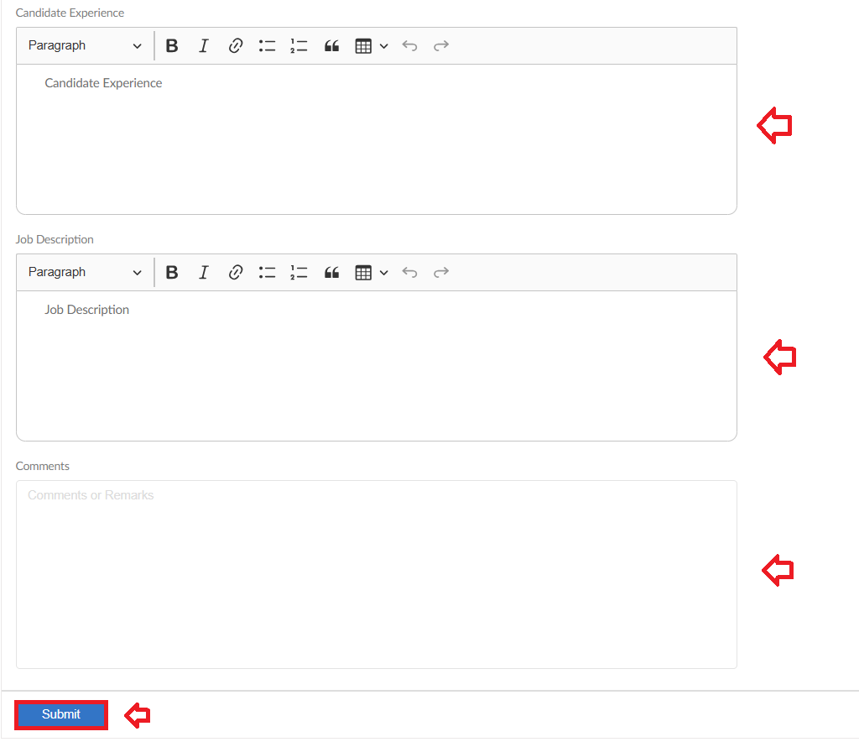
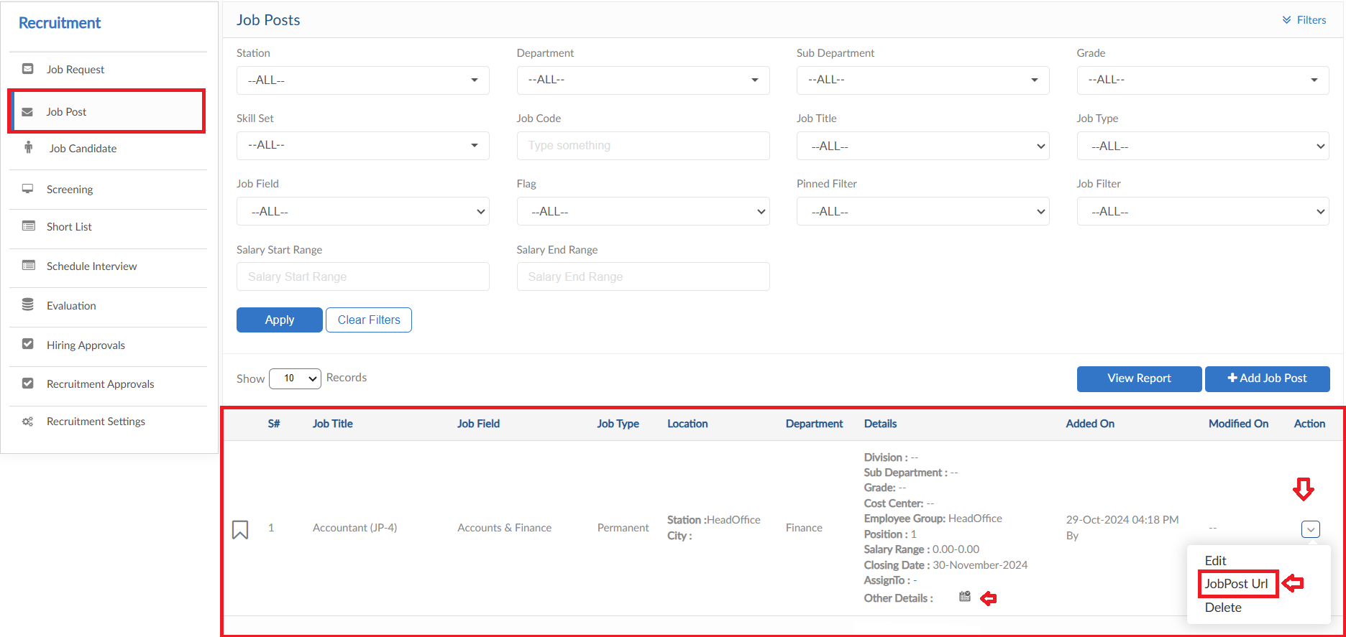
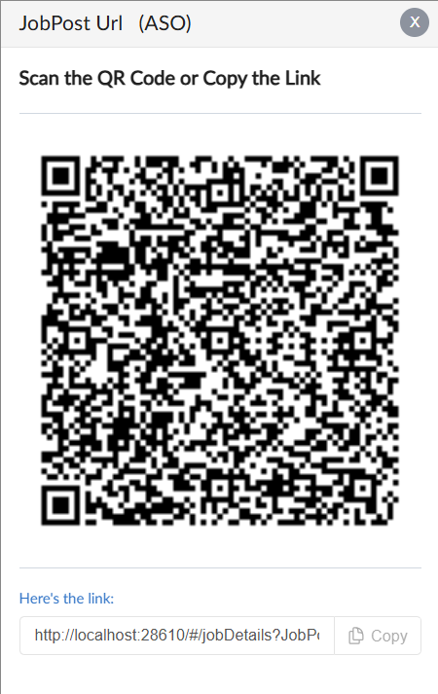

Job Portal

- By accessing the link or QR code provided it will route on the Job Portal
- The Published Job Post can be seen on the Job Portal with details entered
- Candidate can apply for job simply by clicking on Start Application
- To see the other job post of organization, click on Home button

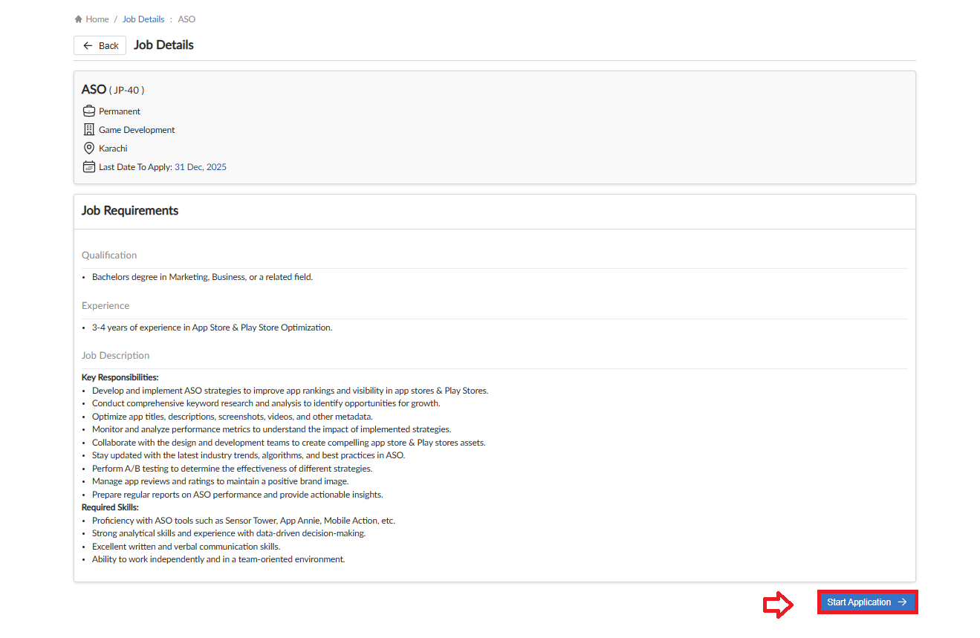

- The Portal shows the list of all Jon Posts
- Candidate can view the details by clicking on Apply Now button or search the required Job title in the search bar
- Top right of the screen share button is given that provides a QR code and link to directly access the Job portal list
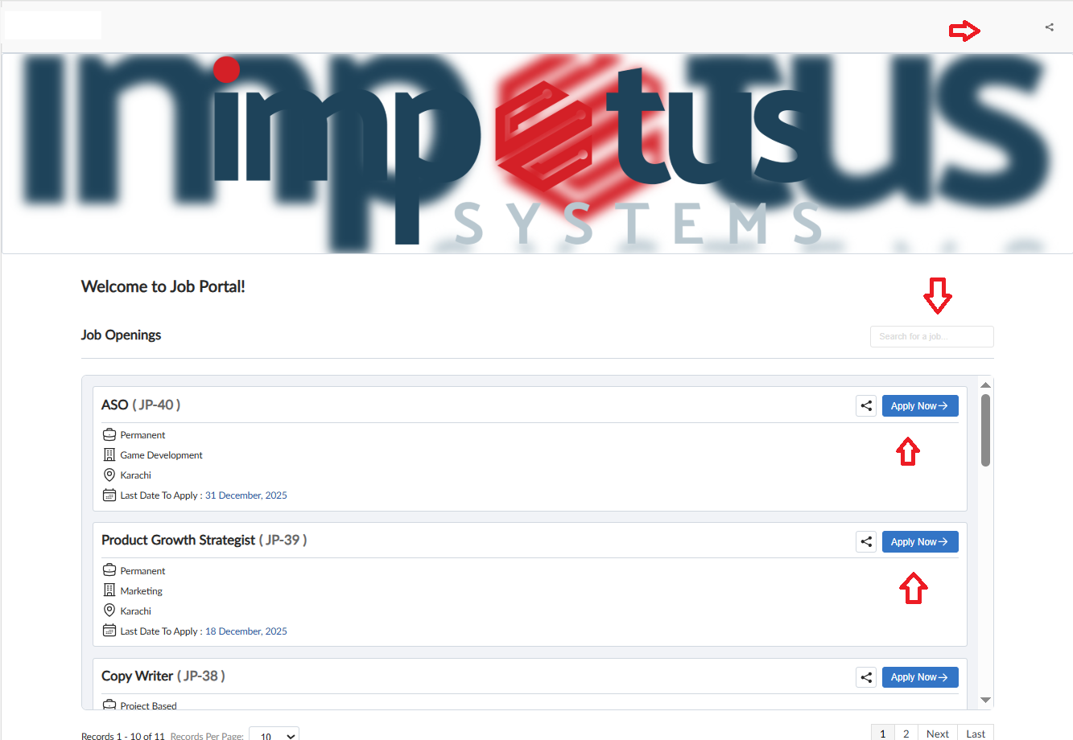
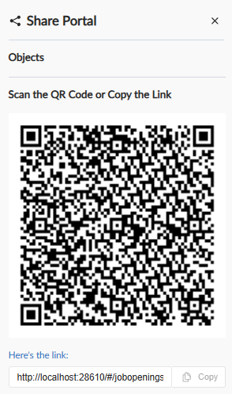

Candidate Portal

- If the check for Candidate Portal is ON while applying for the position the system will show a pop for login else already having an account the candidate will Sign In
- The pop shows 2 options, First to Create Account Second to Continue as Guest (check basis). Applying as guest will directly route towards the application form
- By clicking in Create Account, system requires brief details and email verification
- Captcha is added for security and avoid data breach
- Filling the details and clicking on Create Account button, system will send a verification code on the entered email
- After verification the account will be created, the candidate needs to Sign In using the credentials that were defined
- Candidate Sign In will route towards the Dashboard of Candidate Portal
- Candidate can see all the job openings and track their application
- Click on Apply Now button to fill application for position, enter the required details for the Job Post and click on Submit Application button
- Application form now has ease to drag and drop files
- The Dashboard will show the Job Card with details and Status, whenever candidate application will be moved in Screening the Candidate dashboard will show status and notify as well
- Interview can be re-scheduled through system request (check basis)
- Task Dashboard in Portal will show all the required tasks to be fulfilled by the candidate such as Document upload, Offer Accept/Reject etc.
- Furthermore, the candidate can change the password of portal and edit the profile as well that will automatically fill the Application form if allowed by the candidate
- The organization can list their Vision/Goals in the bottom of dashboard
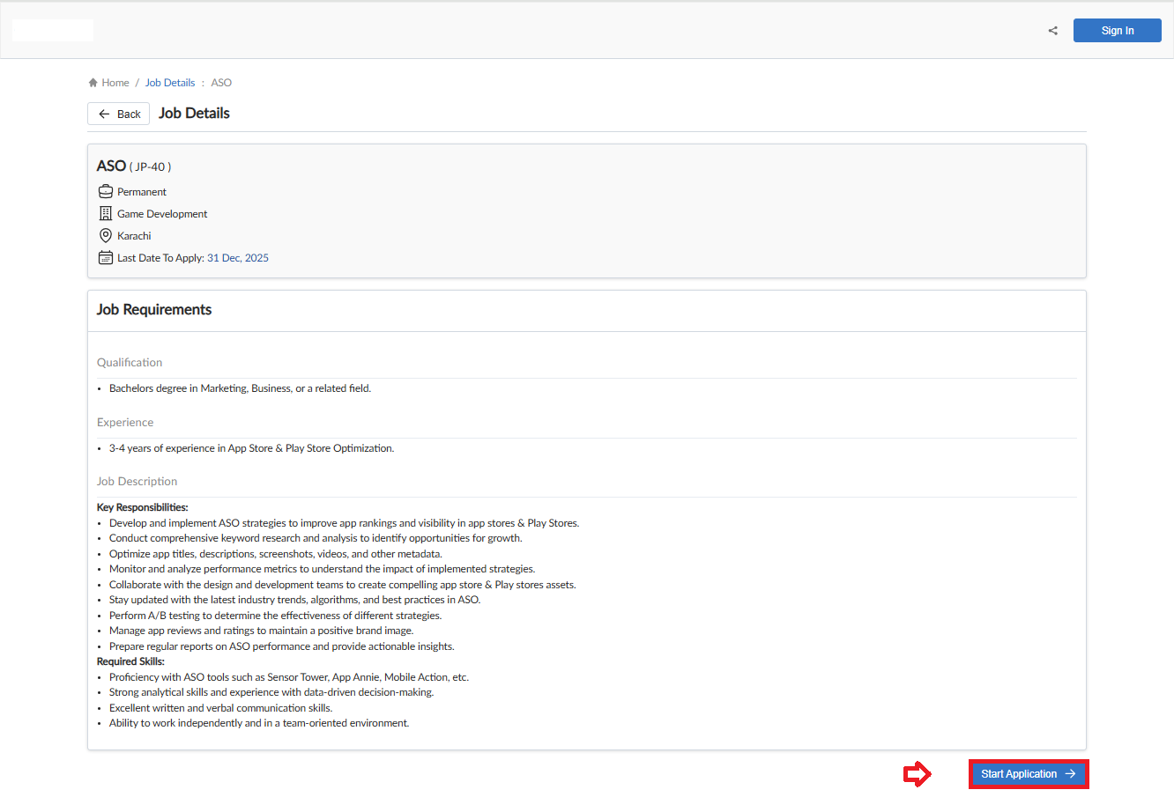
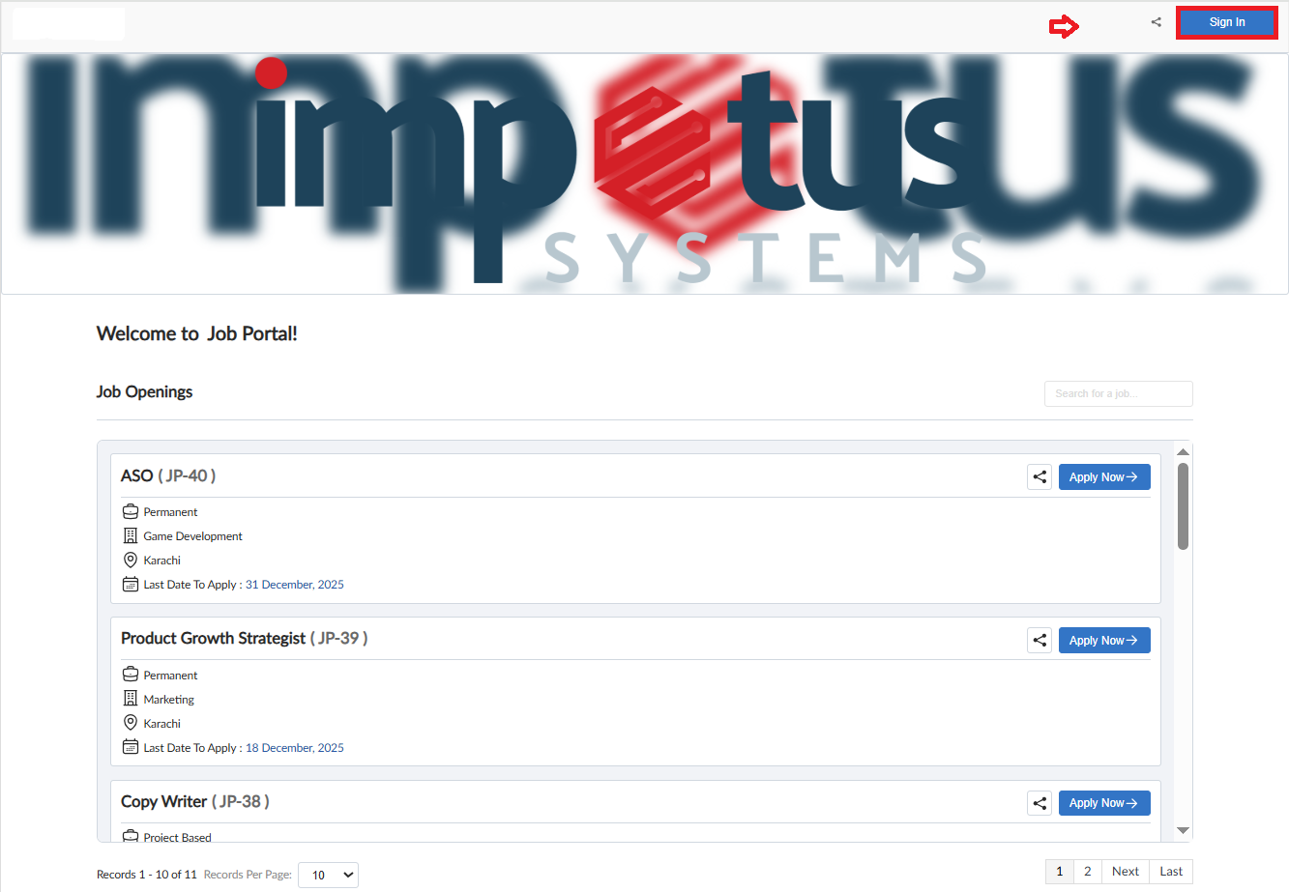
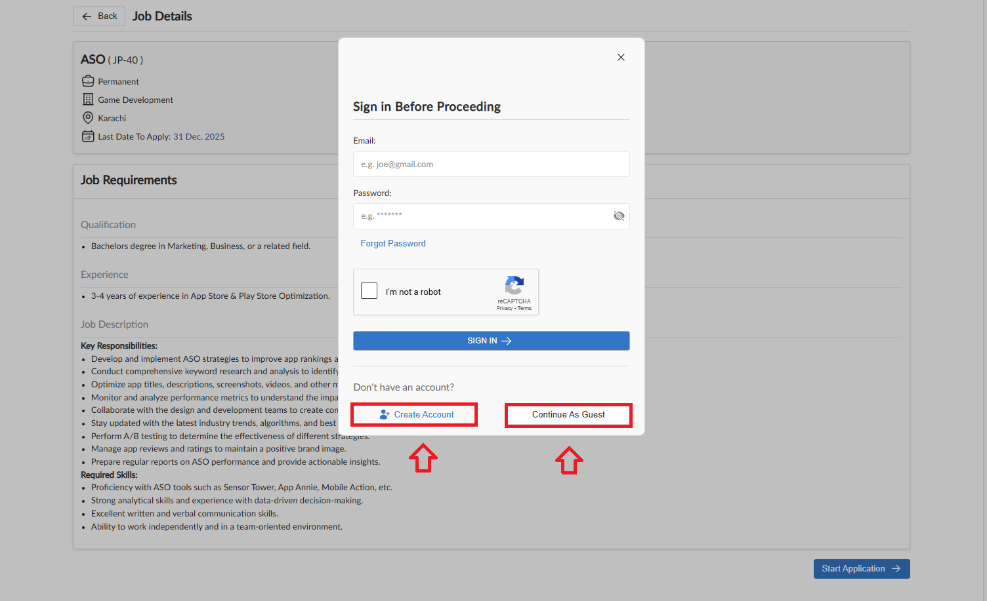
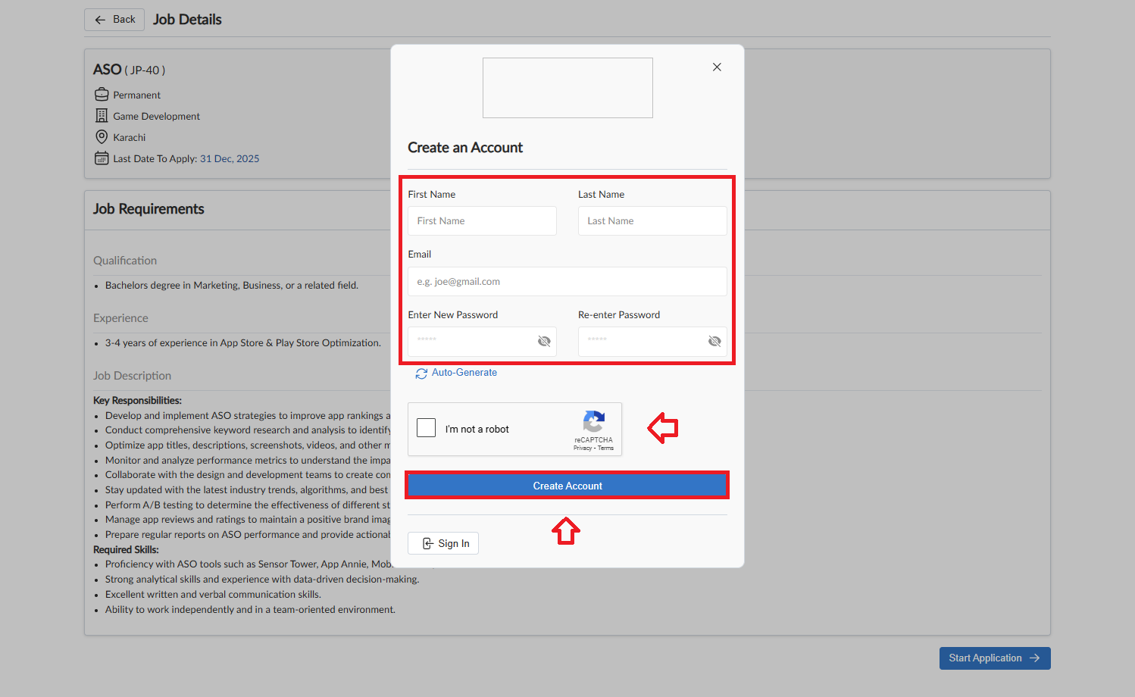
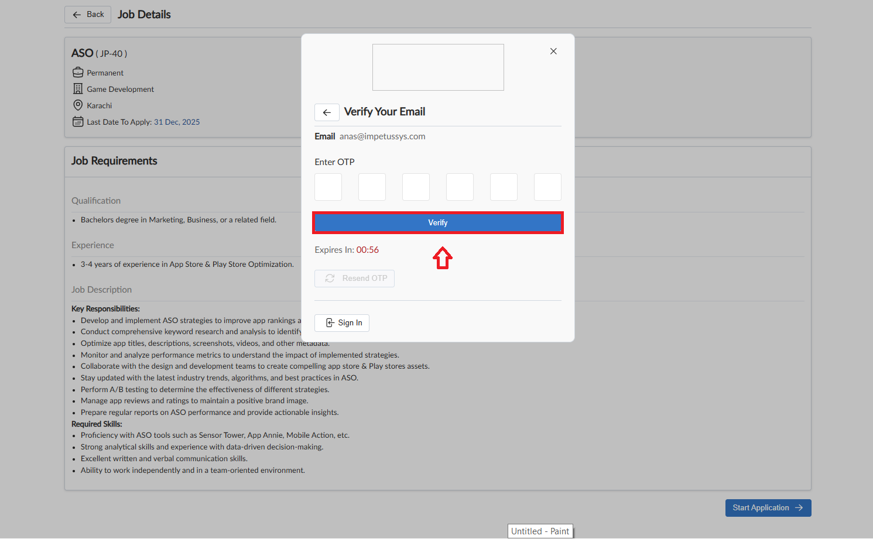
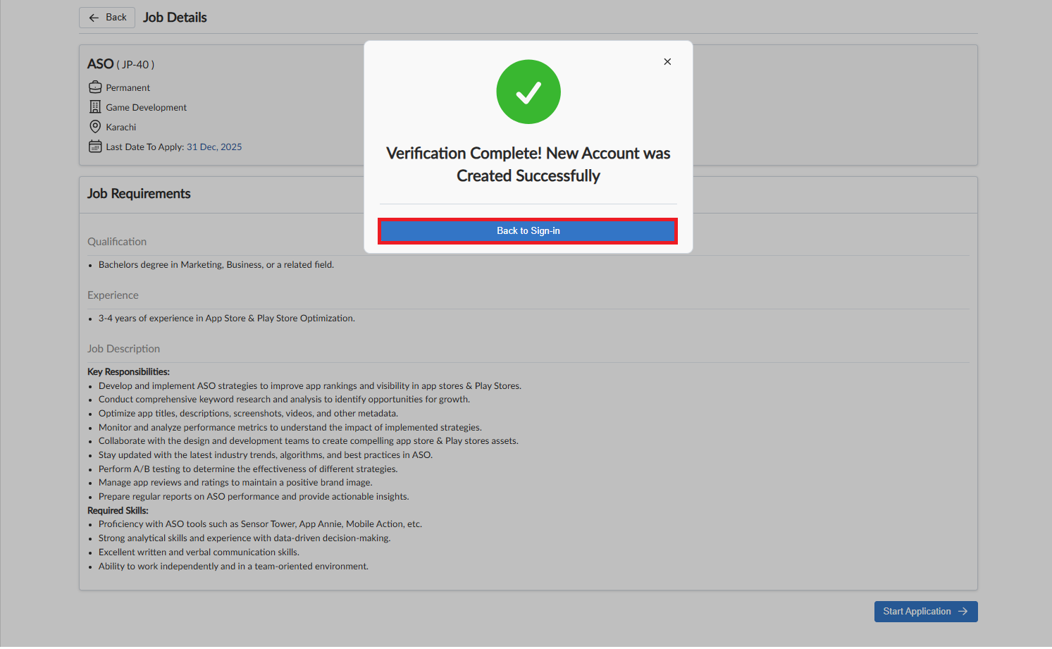
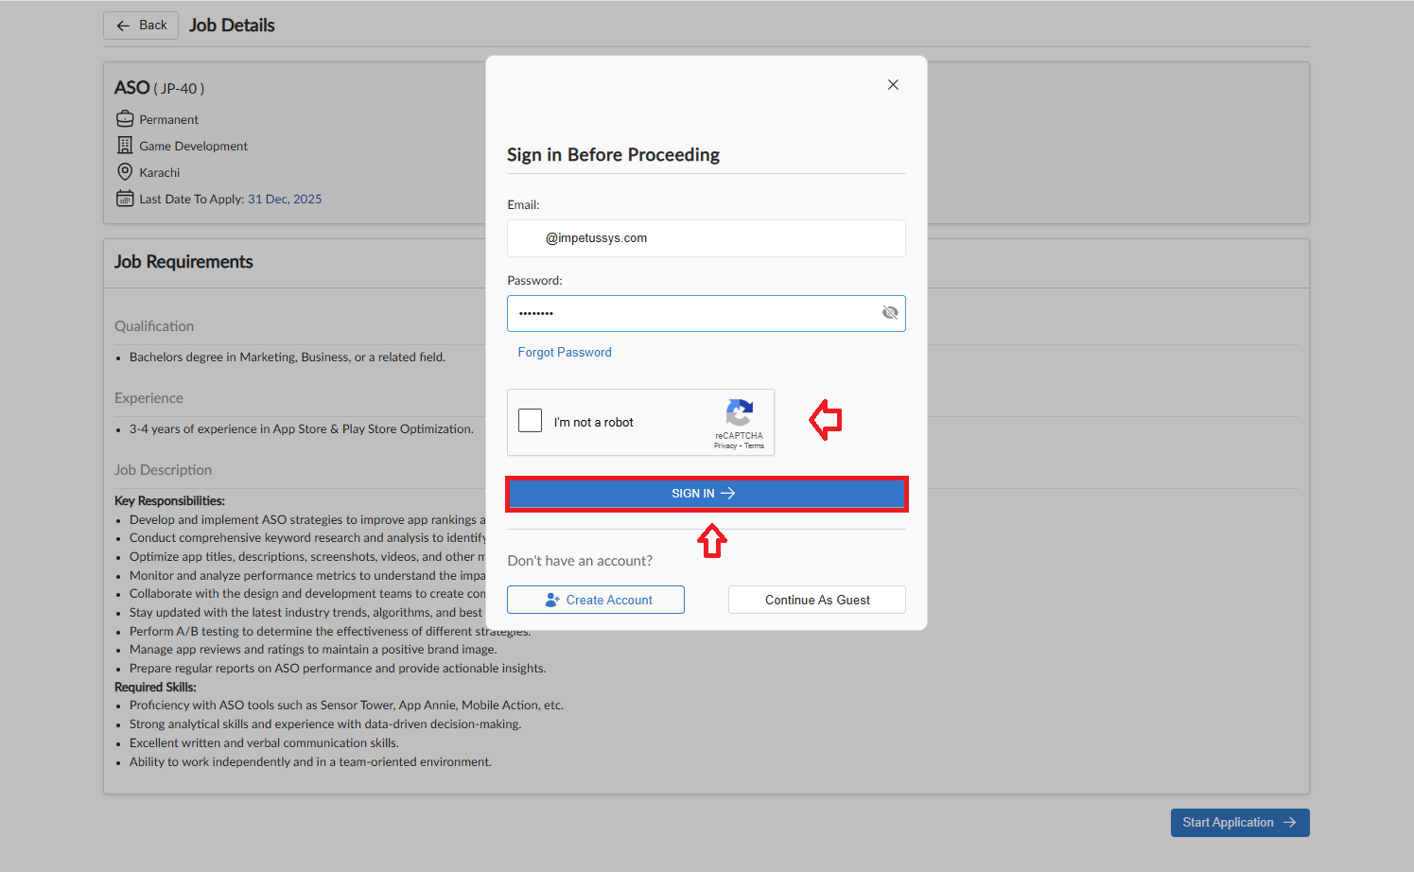

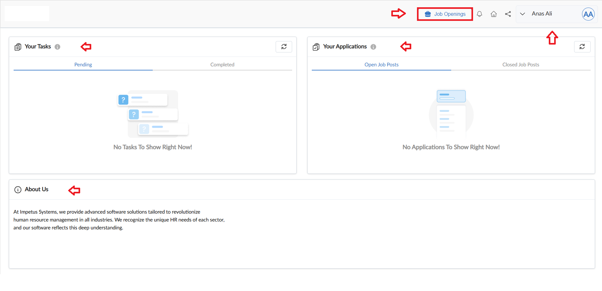
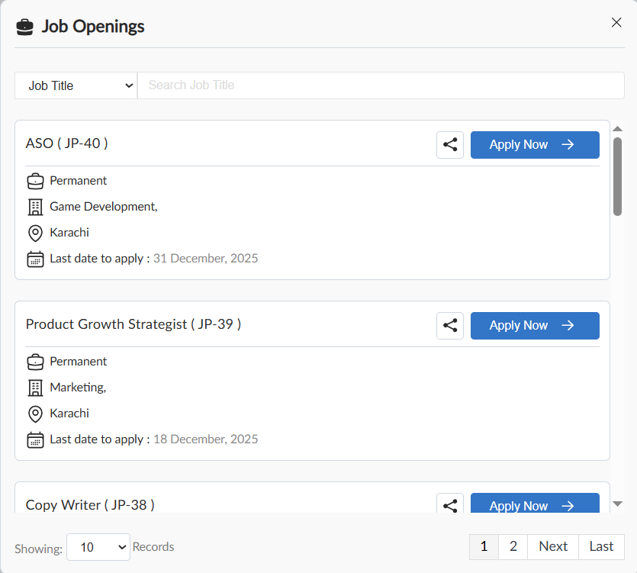
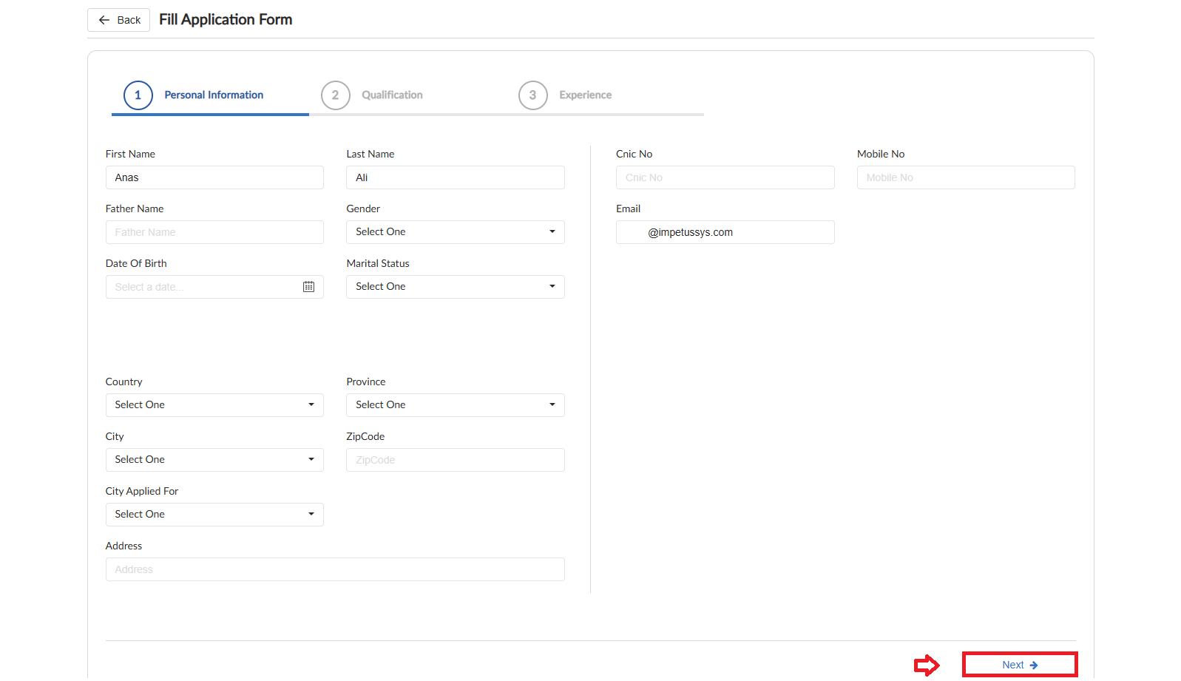
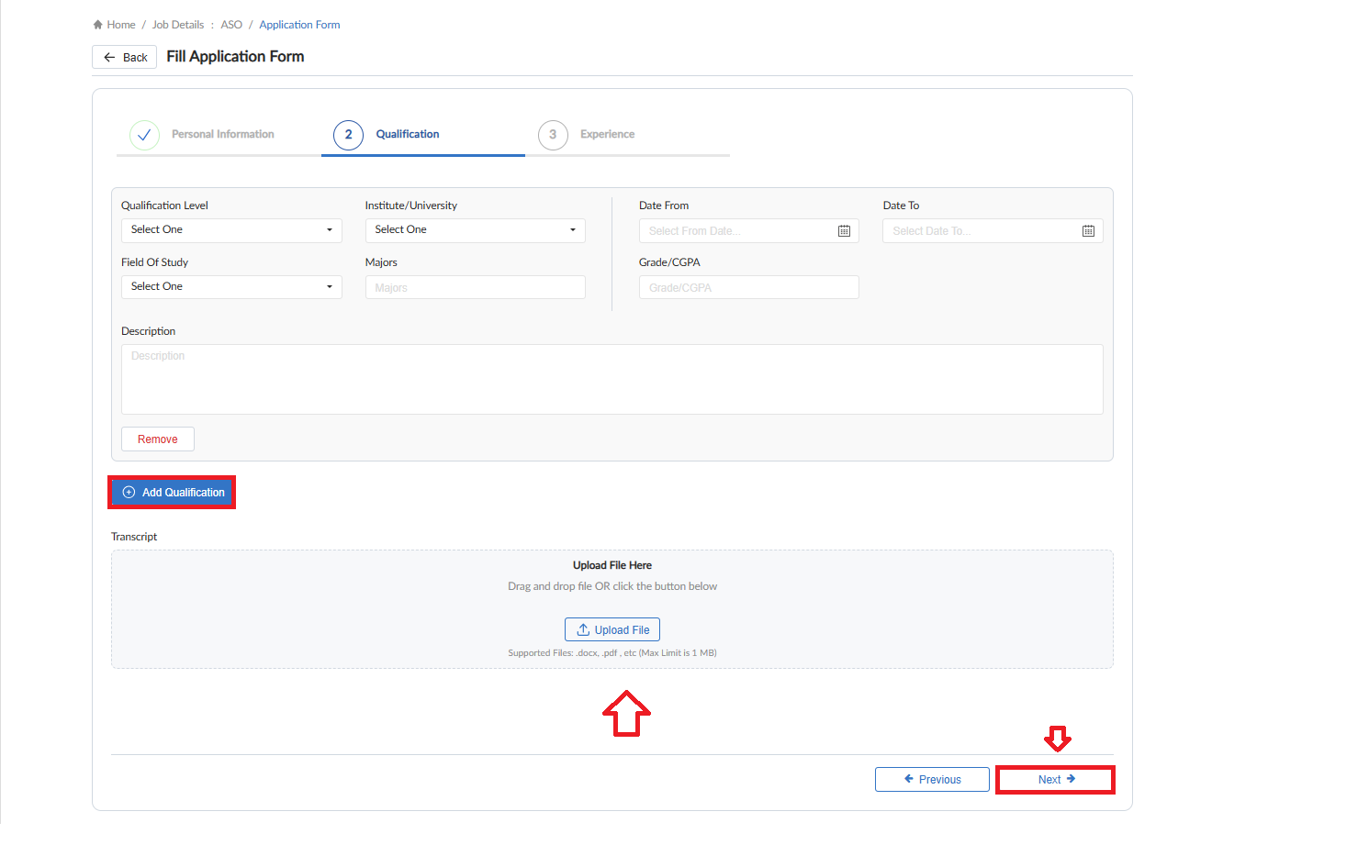
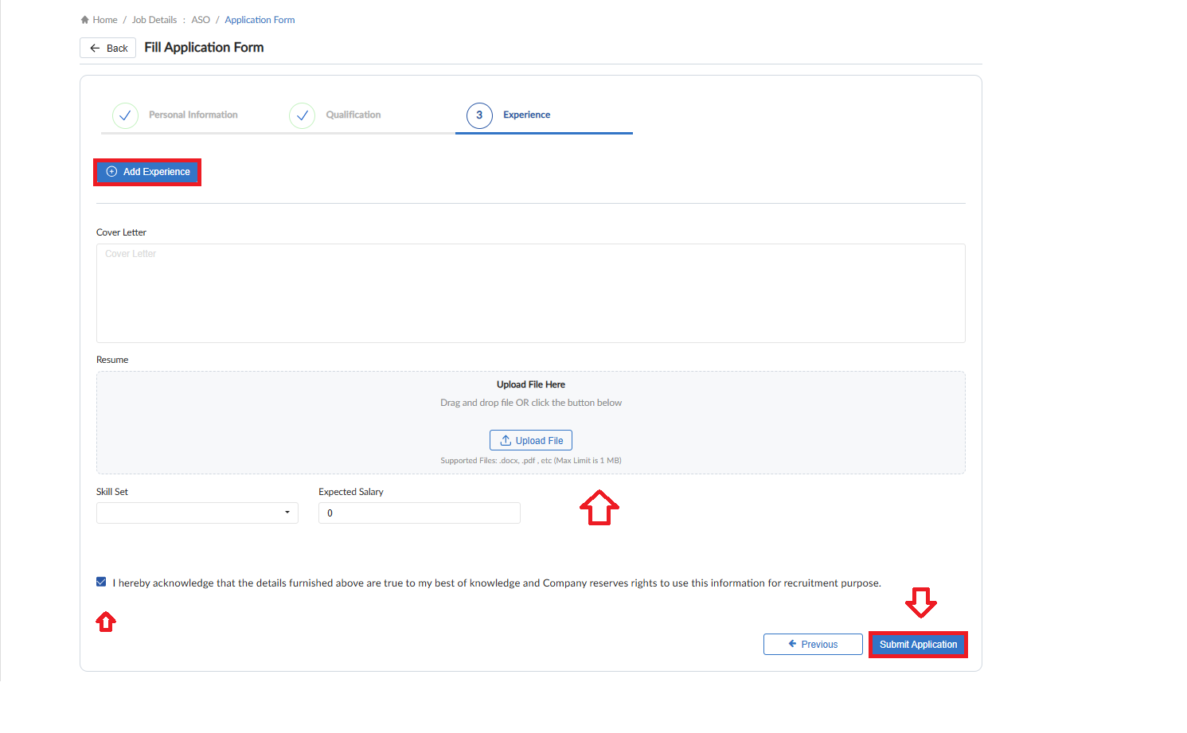
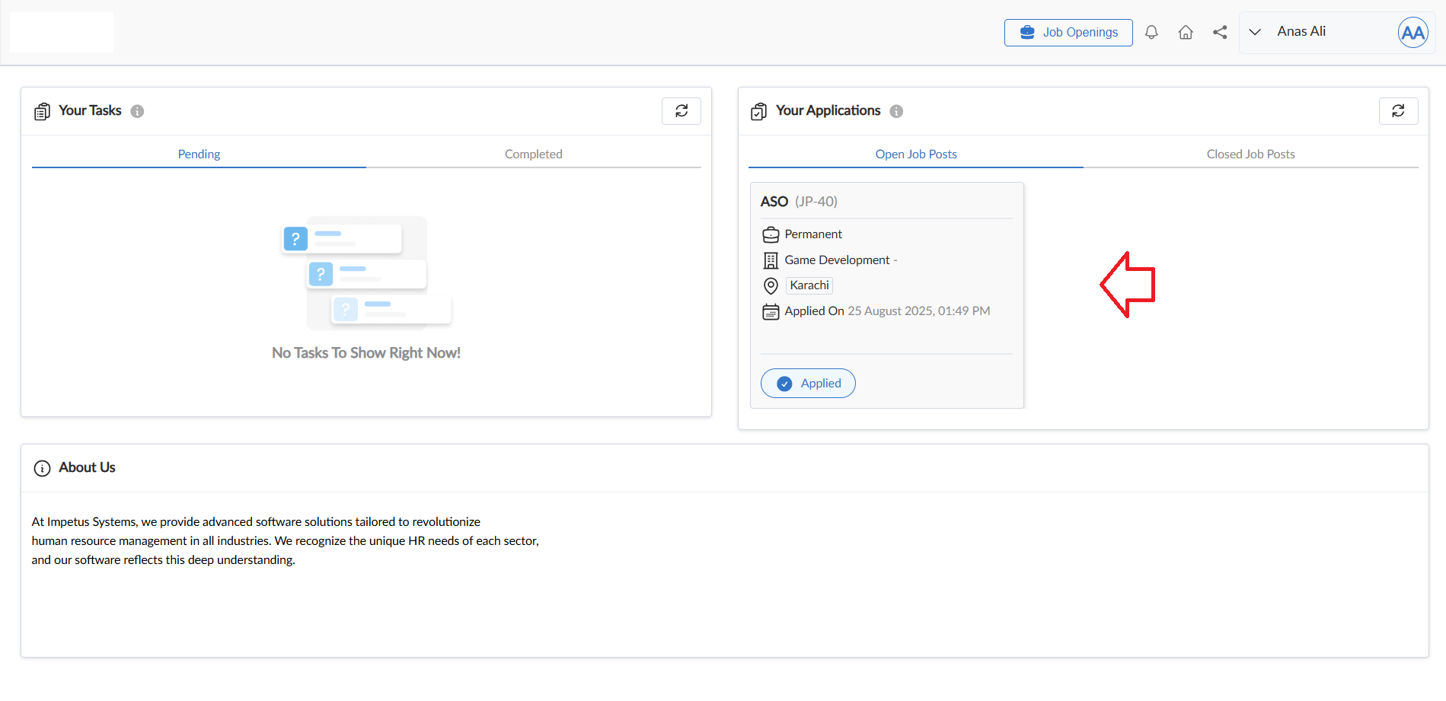
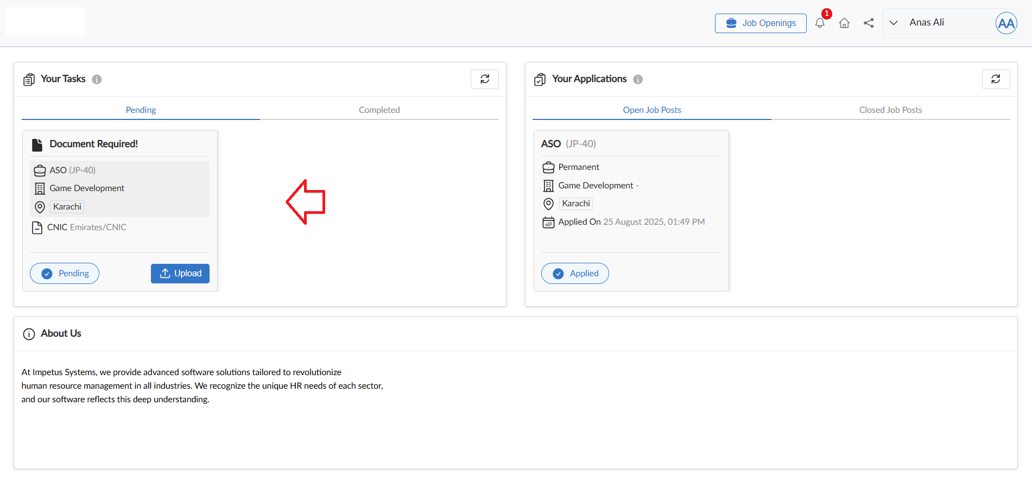

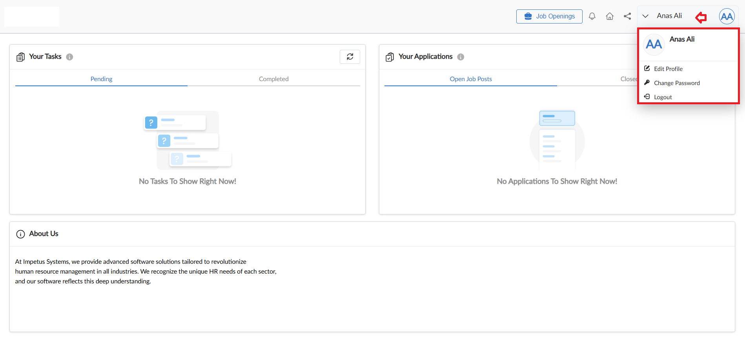

View Report
- To view the data of grid in Job Post form click on view report
- Job Post Report will pop up on screen

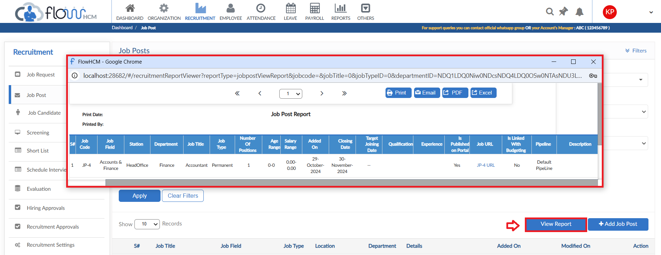

Job Candidate

- To add a Candidate, click on Add Job Candidate
- Select the template and then click Add
- The form is divided into Three Tabs accordingly
- Fill out the details in fields and selection from dropdowns
- Then click on submit
- The candidate’s data can be seen in grid, click on Action button for additional features
- Click on Apply for Job to make part of any ongoing screening
- The candidates applying online through Job/Candidate Portal will automatically fill the grid and be part of Screening process
- Applications through Candidate Portal have an additional Tab of documents
- Any candidate can be marked Blacklisted through Job candidate form

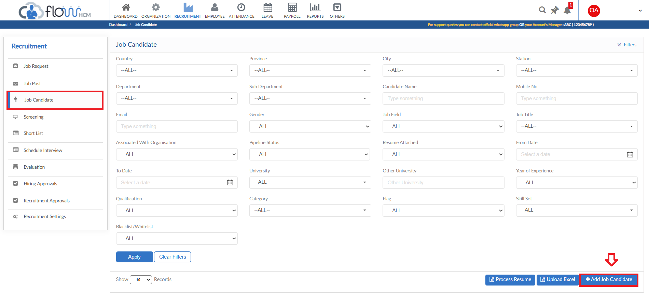
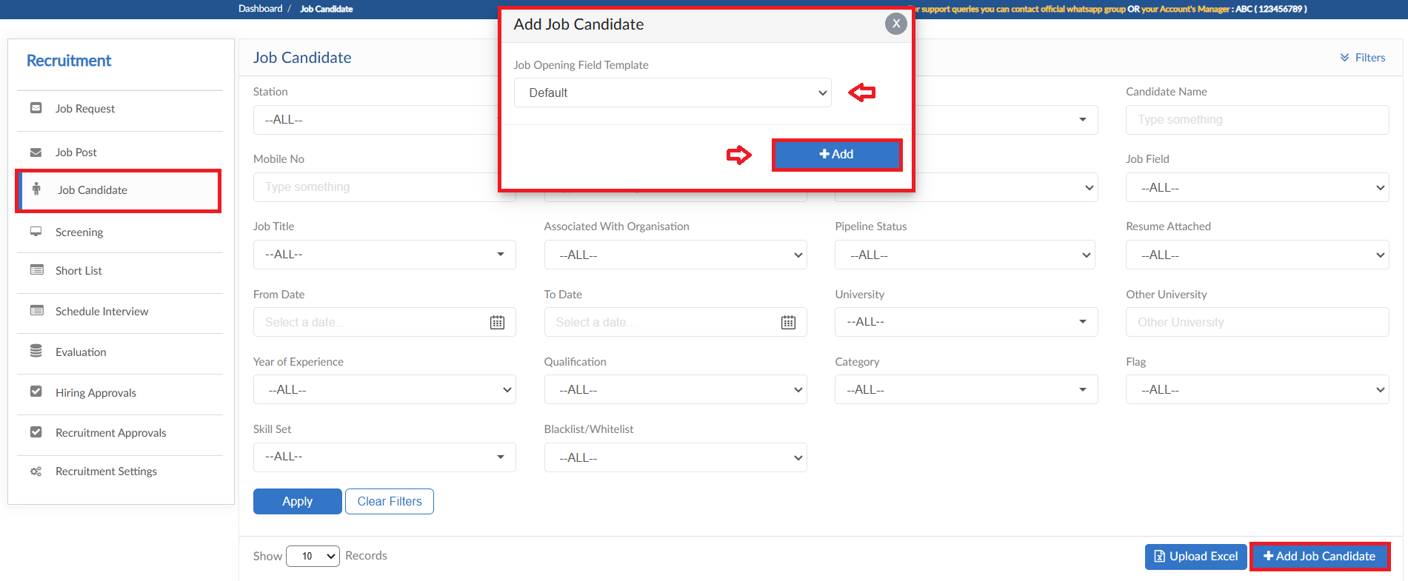
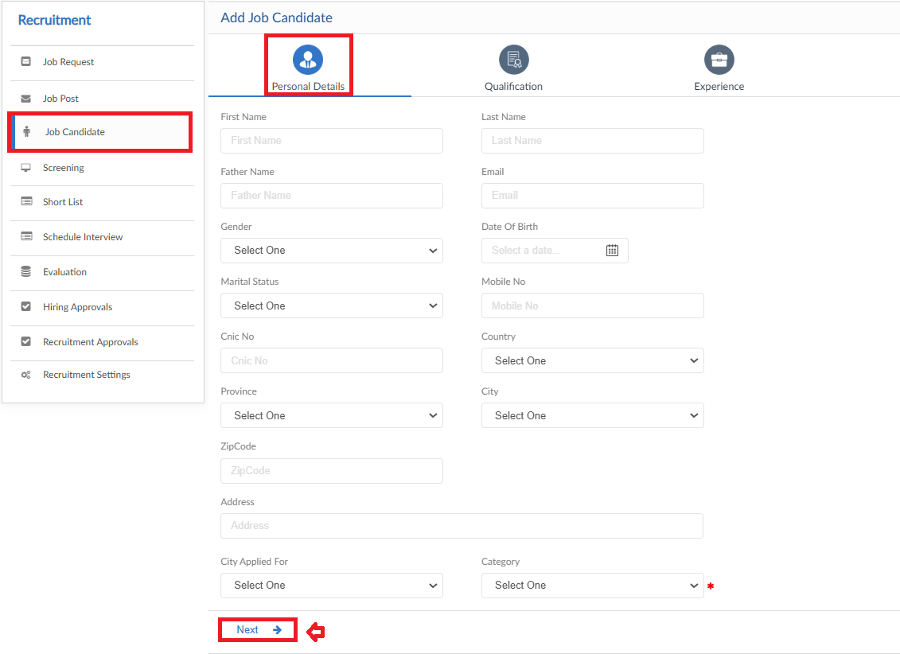
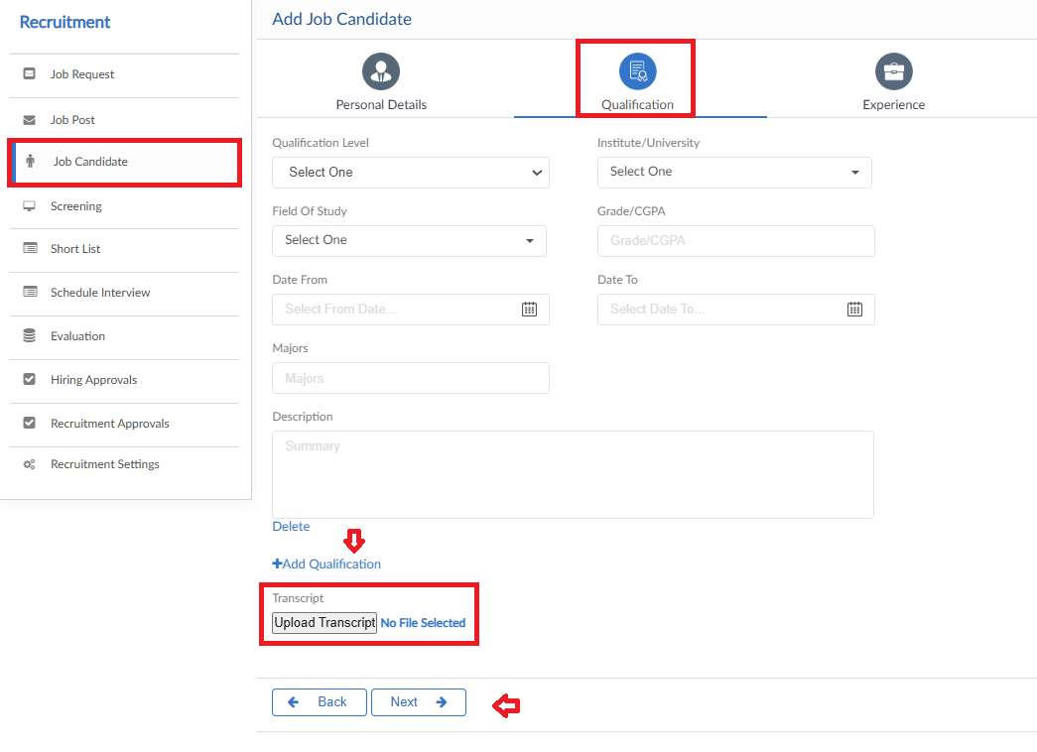
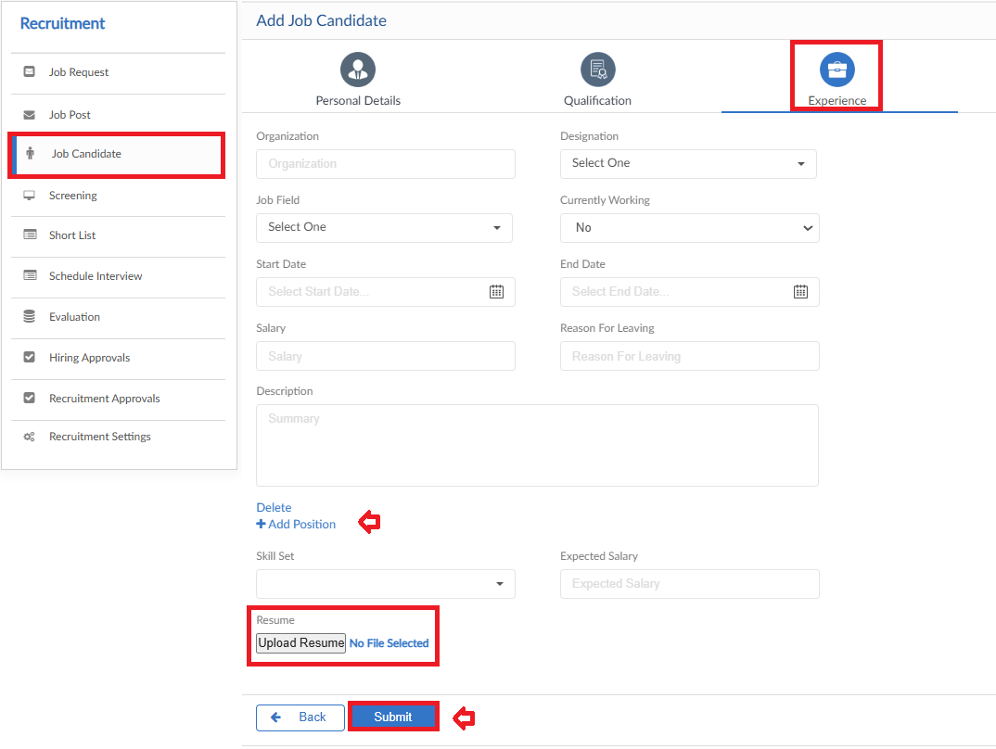

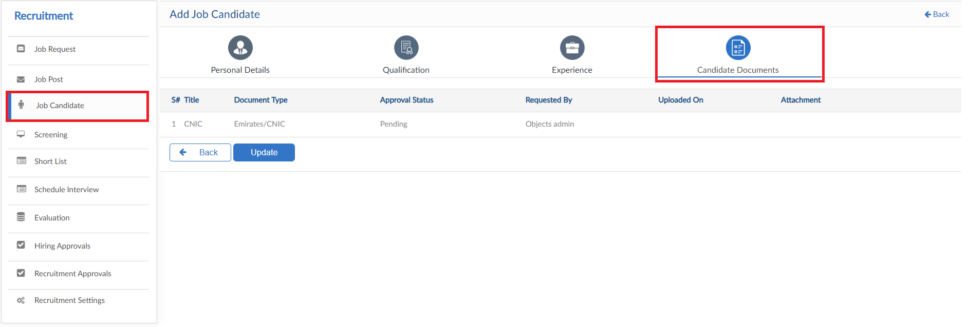
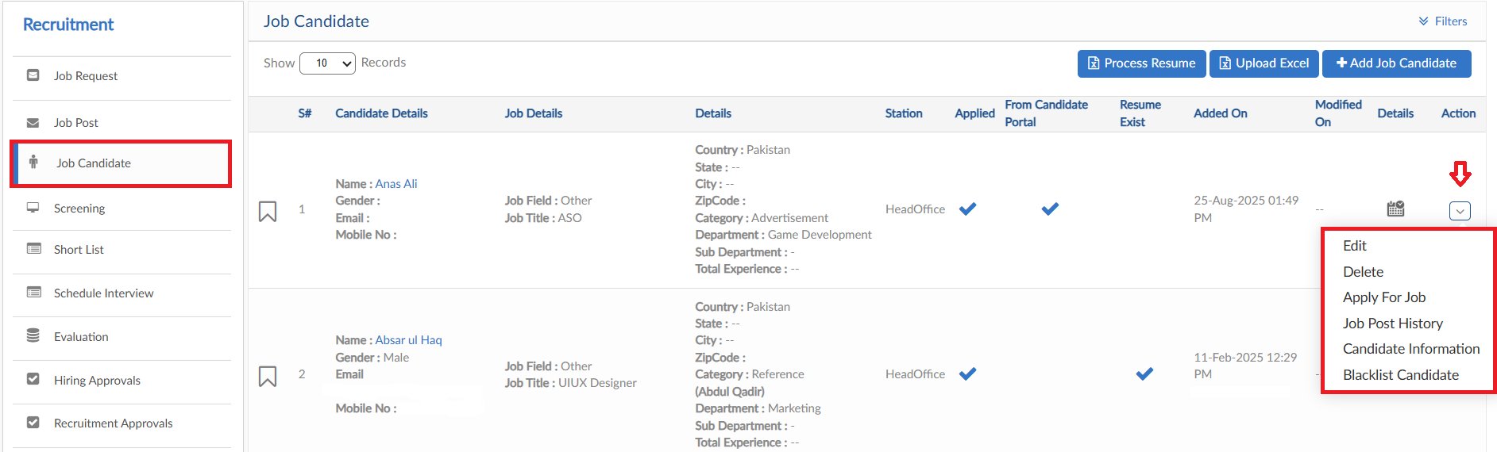
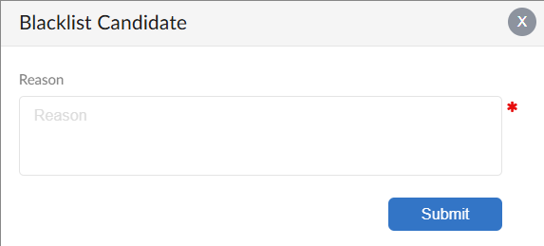
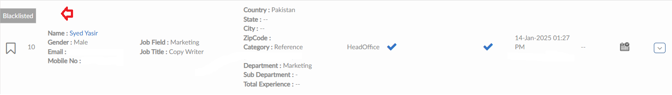

Upload Excel
- If required, upload all candidate data in one go user can use upload excel
- Click on Upload Excel button, pop up will be visible
- Select the Job Opening Field Template and click on Next
- Then click on Download Sample Template and enter required data
- Click on choose file and then click on Save button to upload all Worksheets

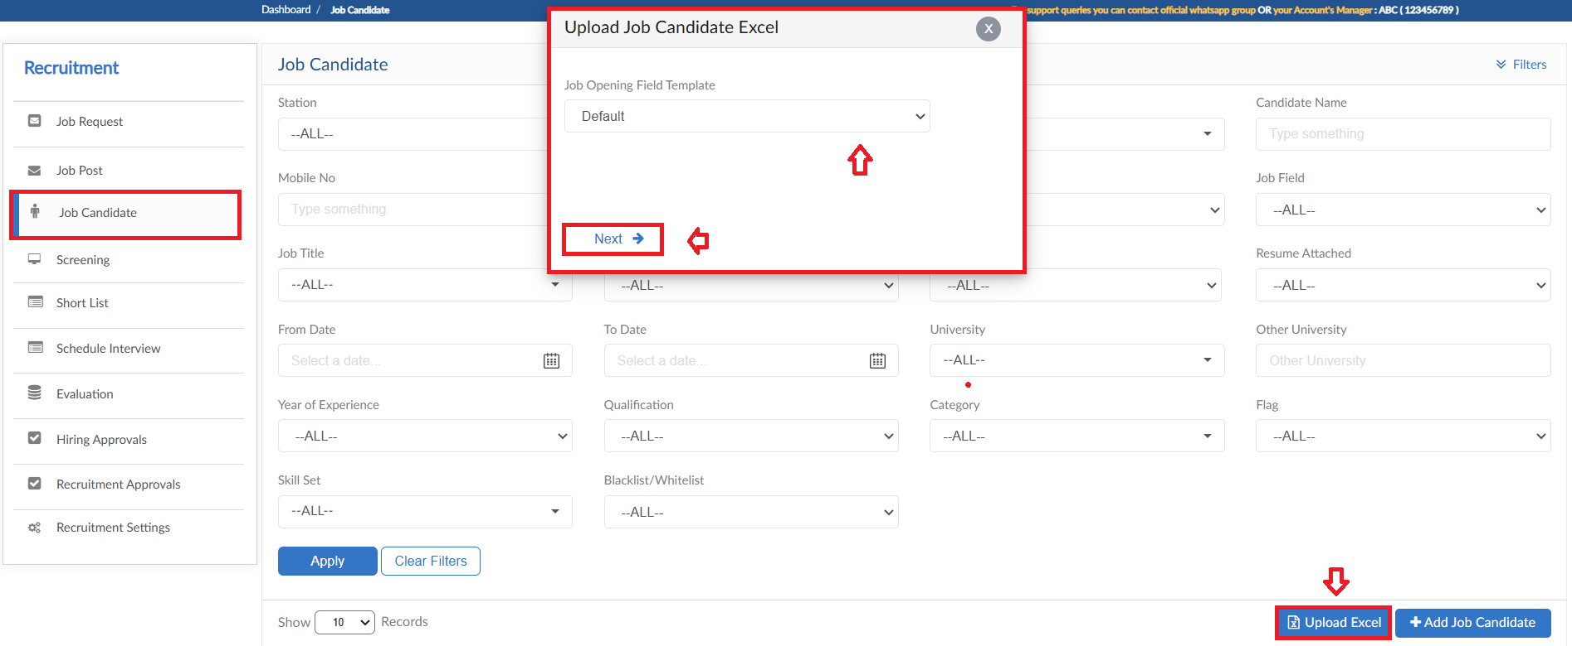
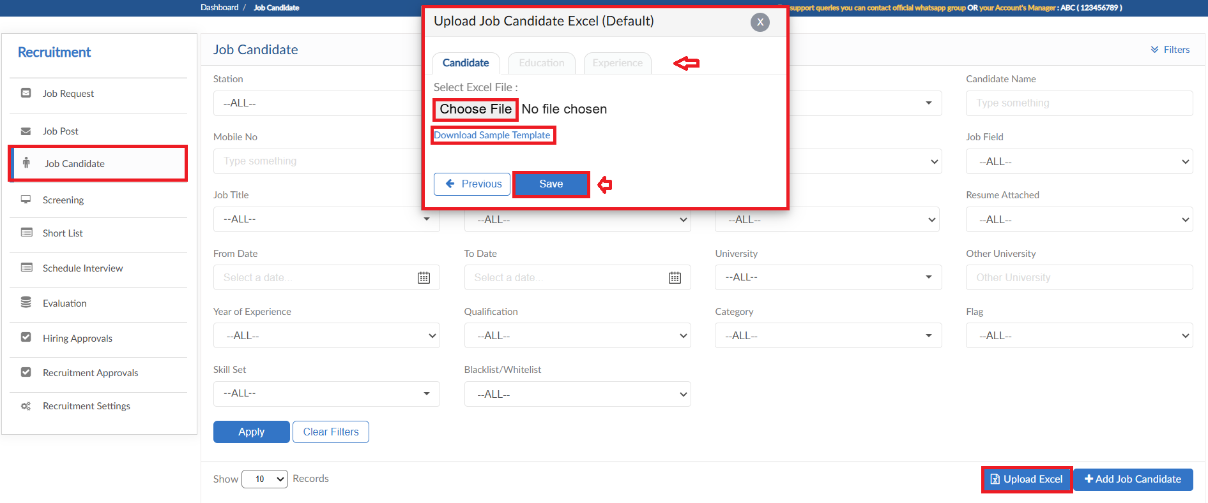

Process Resume
- This feature will parse all the resumes of candidates for CV parsing in screening form
- System will also list down the candidates against no resumes are found
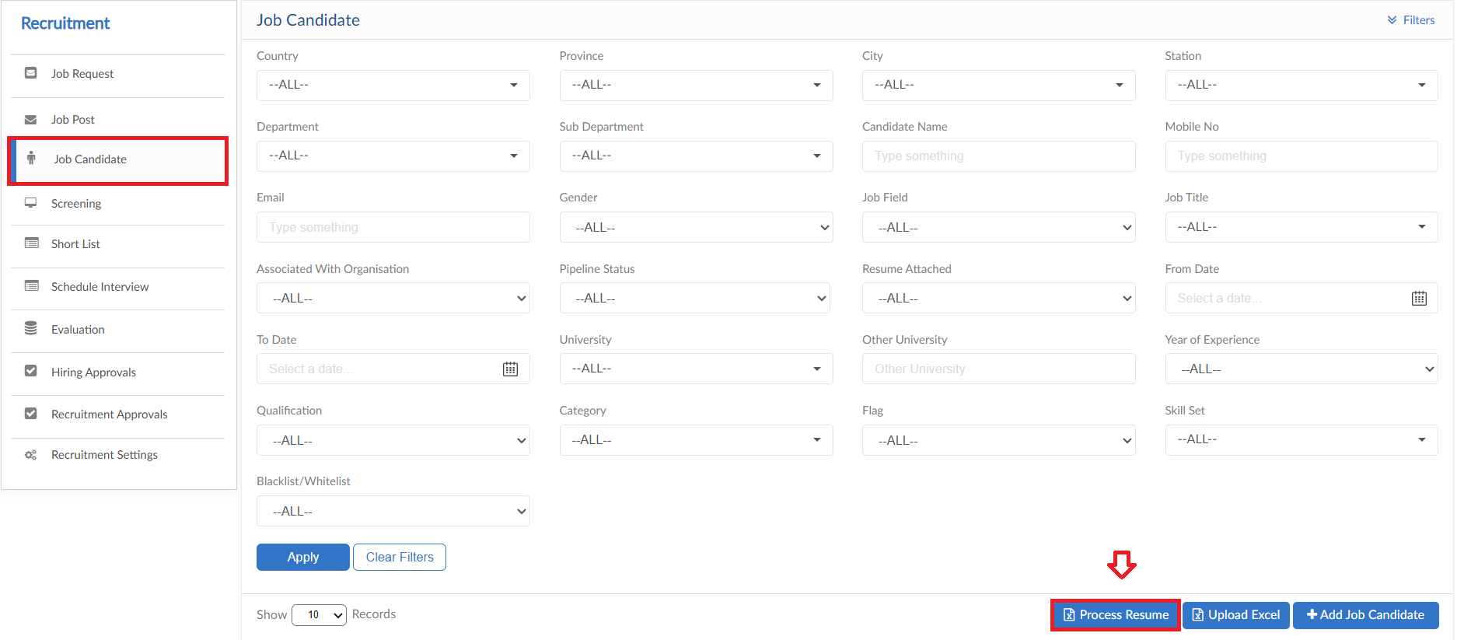

Screening

- To see all the Job Posts (Open/Closed) progress, click on Screening
- The form will show all the Job Posts along with the count of applications on each pipeline tile
- Click on any Job Post to perform further actions
- Applicant Job cards can be moved like widgets between the tiles
- Every tile on screening perform different functionality and show the progress of candidate

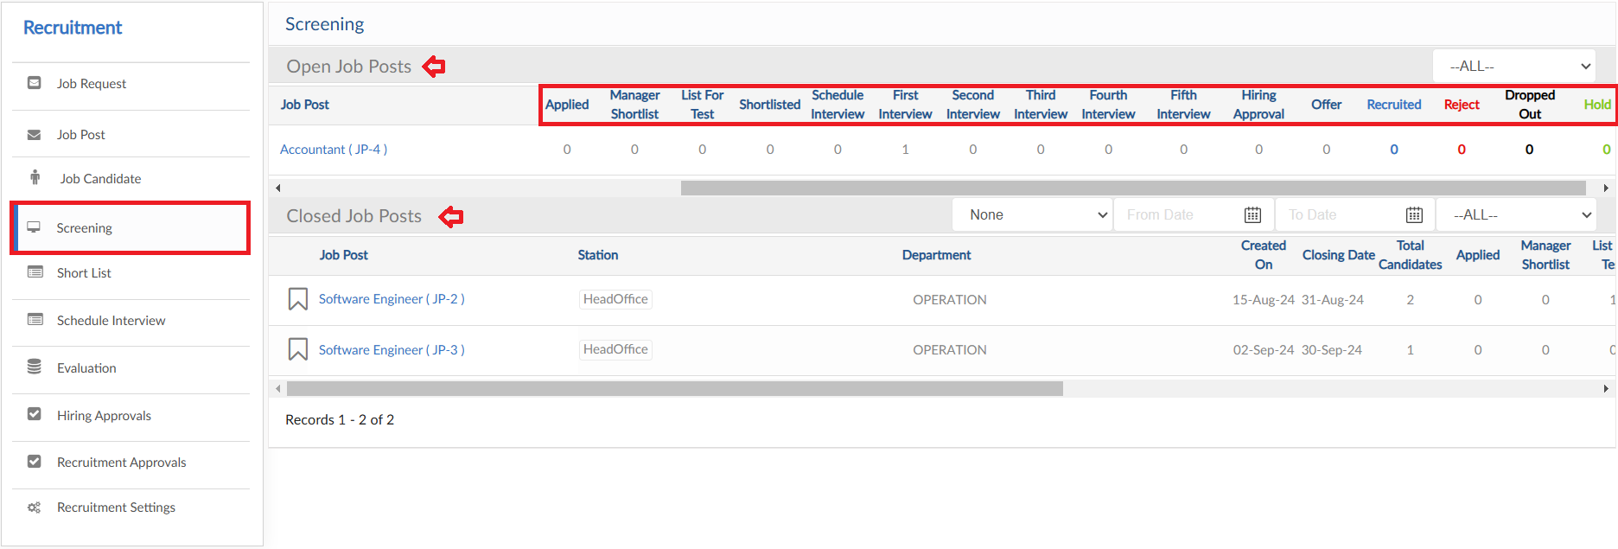
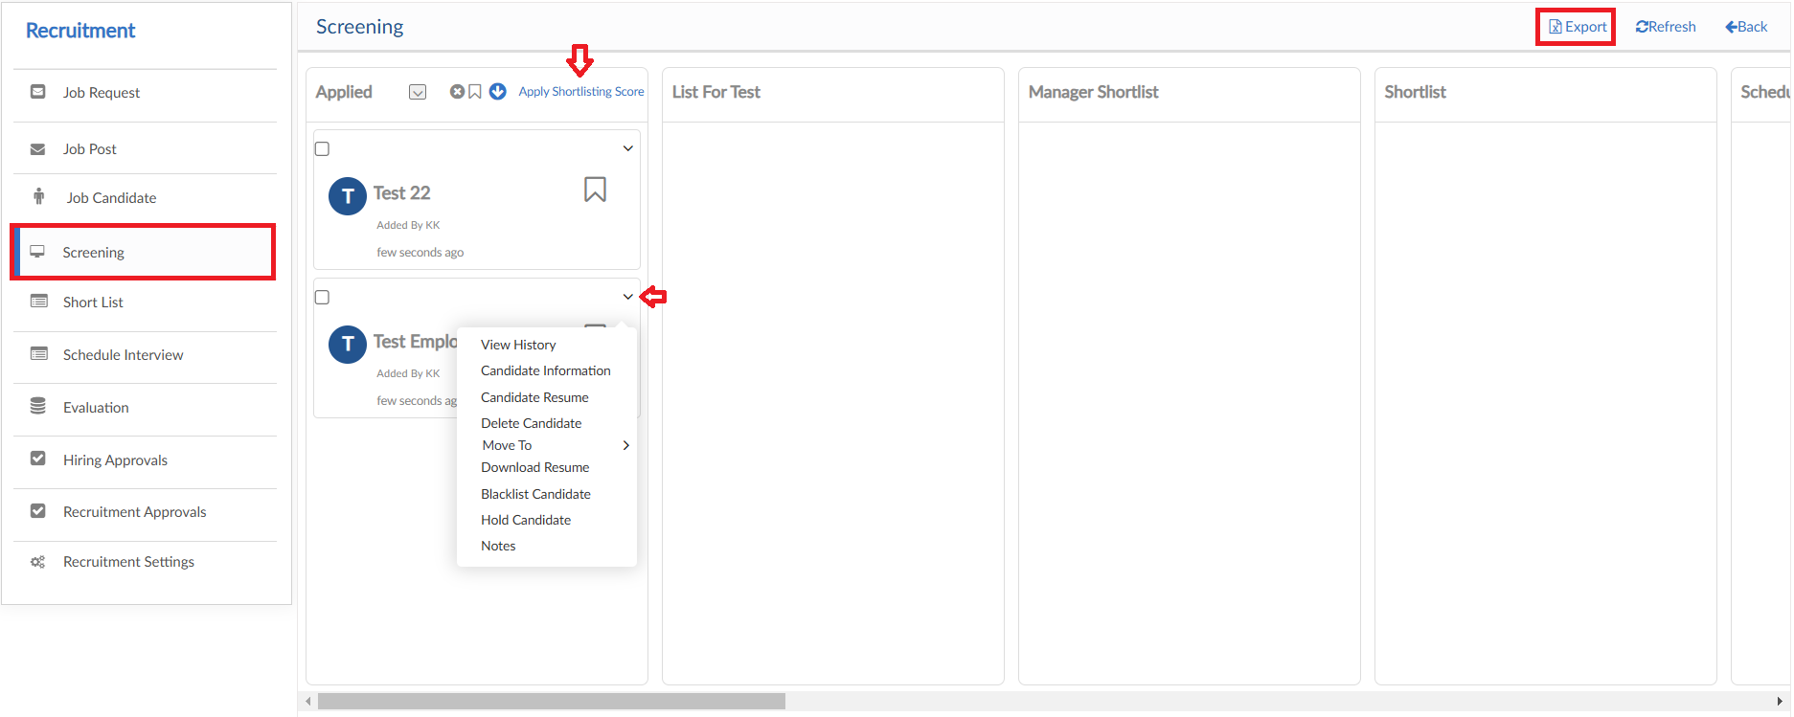

CV Parsing
- Click on Search icon to enable the search bar for keyword
- Enter the required keyword, the system will parse all the data and filter the candidates from Applied tile
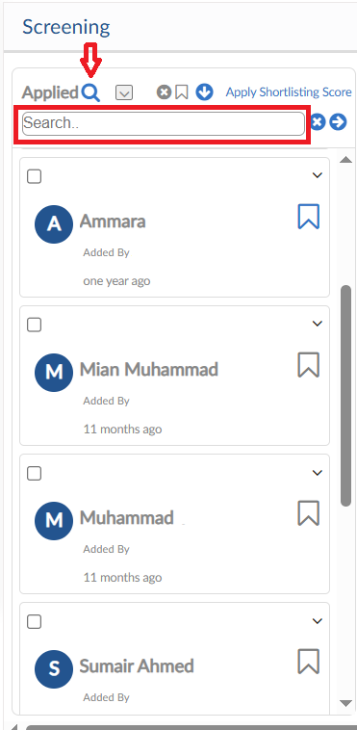

Apply Shortlisting Score
- Apply Shortlisting Score feature provides the candidates from Applied tile through filter criteria
- Select the required data from dropdowns and give marking
- Keyword search can also be processed
- Click next to filter the candidates, select the candidates required
- Move the selected candidates to another pipeline tile

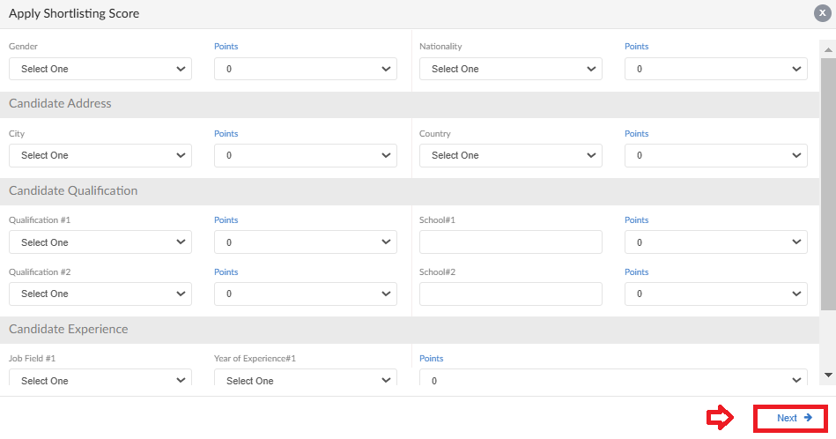
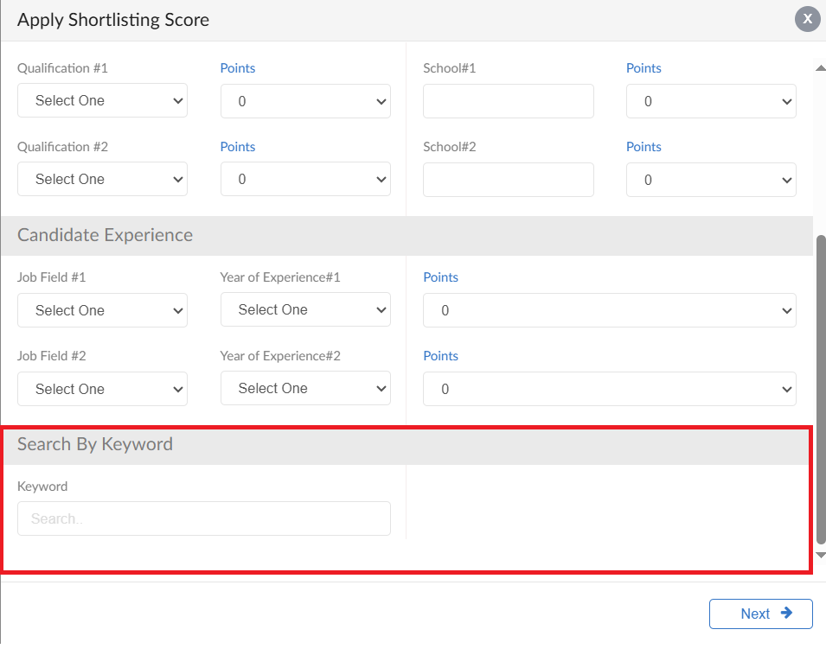
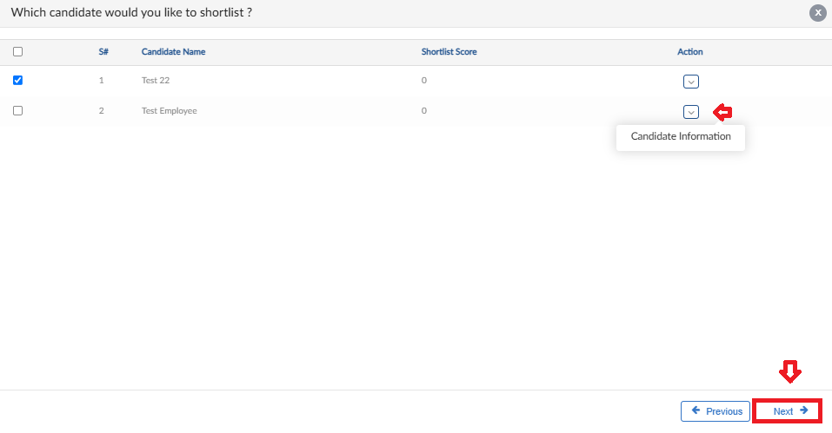
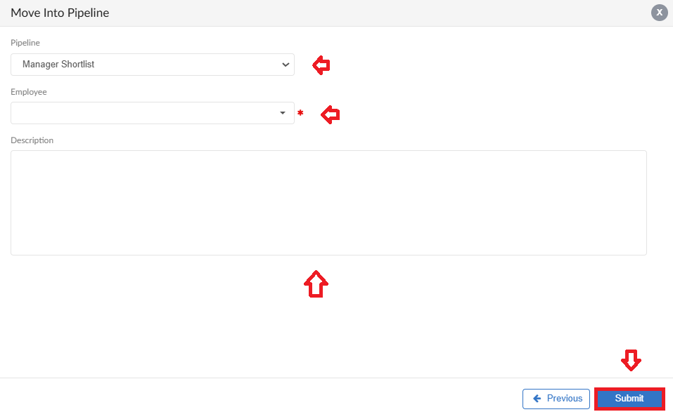

List for Test
- Candidate on List for Test file
- Marks for test and attachment option is available

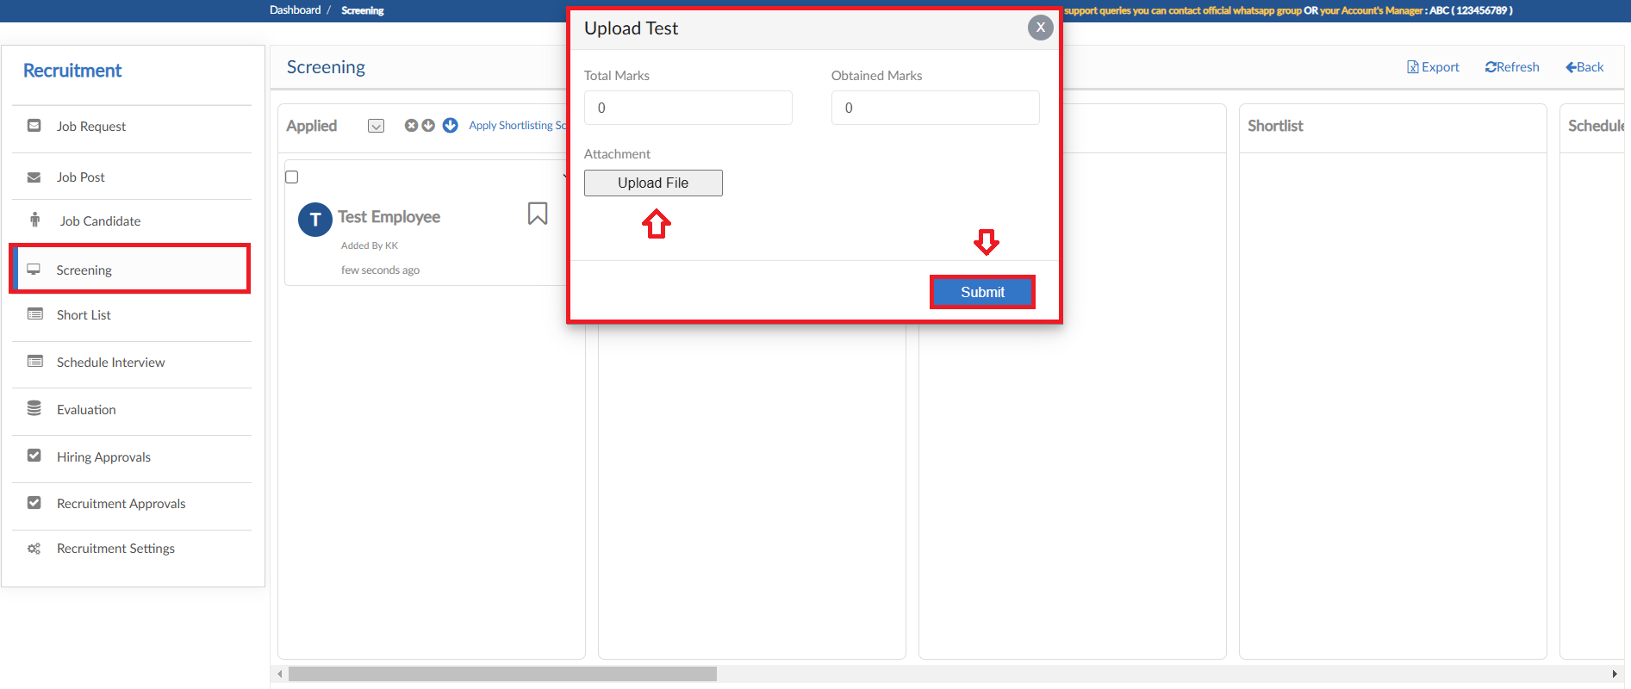

Manager Shortlisting
- Manager Shortlisting tile feature allows to send multiple candidates to an employee
- Then employee can view the details of each candidate and shortlist them

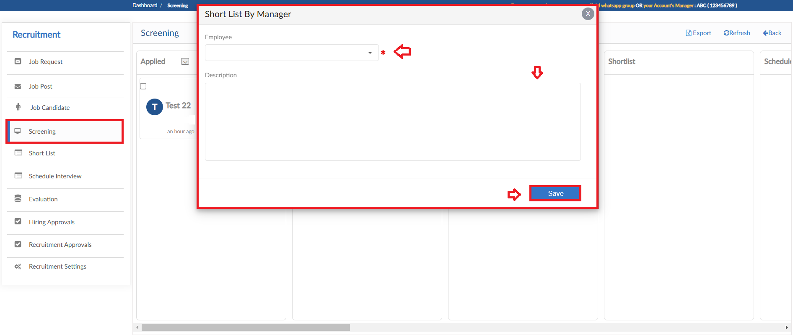

Schedule Interview
- Schedule Interview tile feature allows to select candidates to be scheduled for interview
- Then the employee can schedule the interviews of candidates

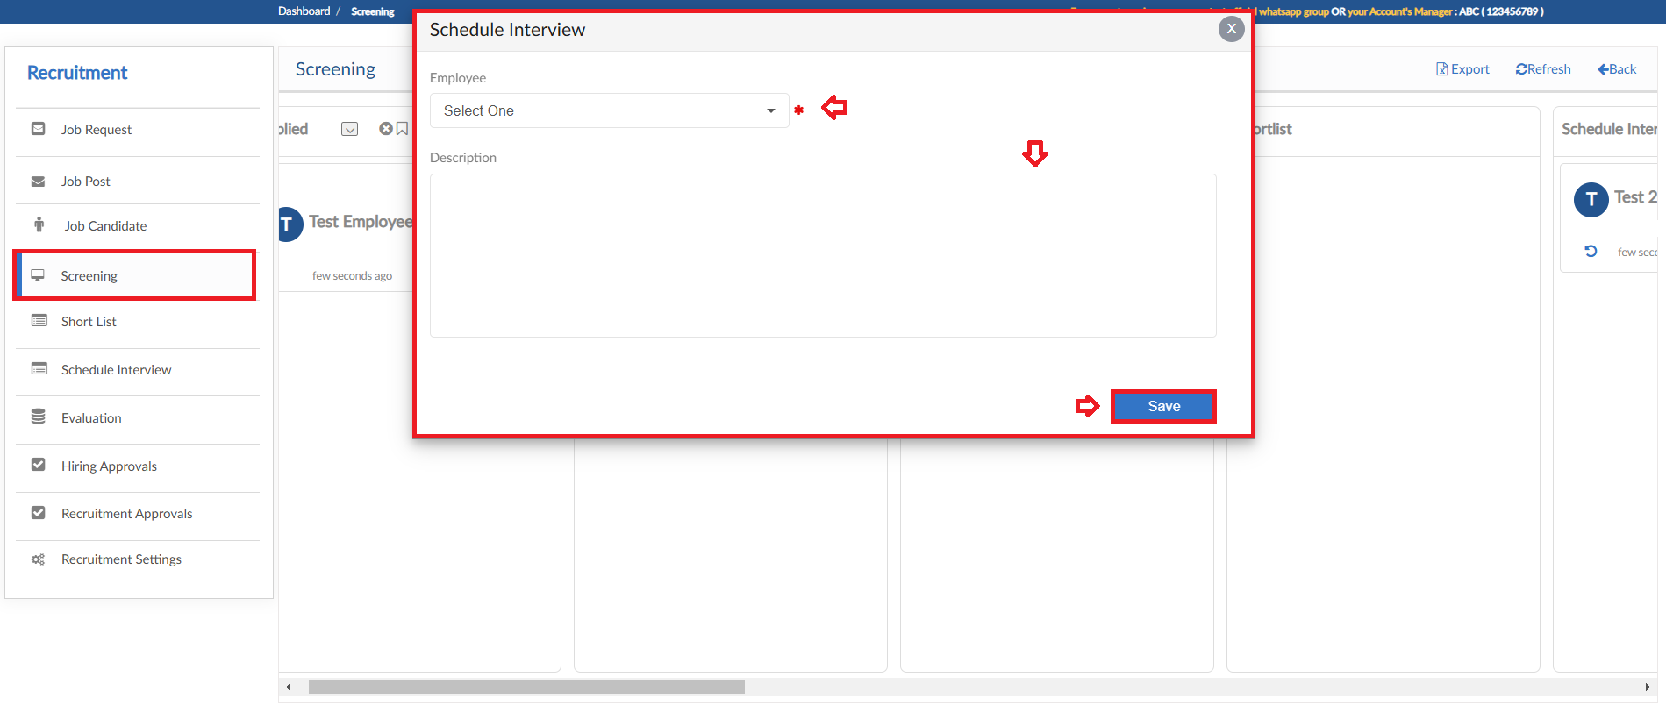

Interview (1st, 2nd, 3rd ....)
- Interview tiles feature allows to schedule an interview
- Interview details can be entered and click Save button

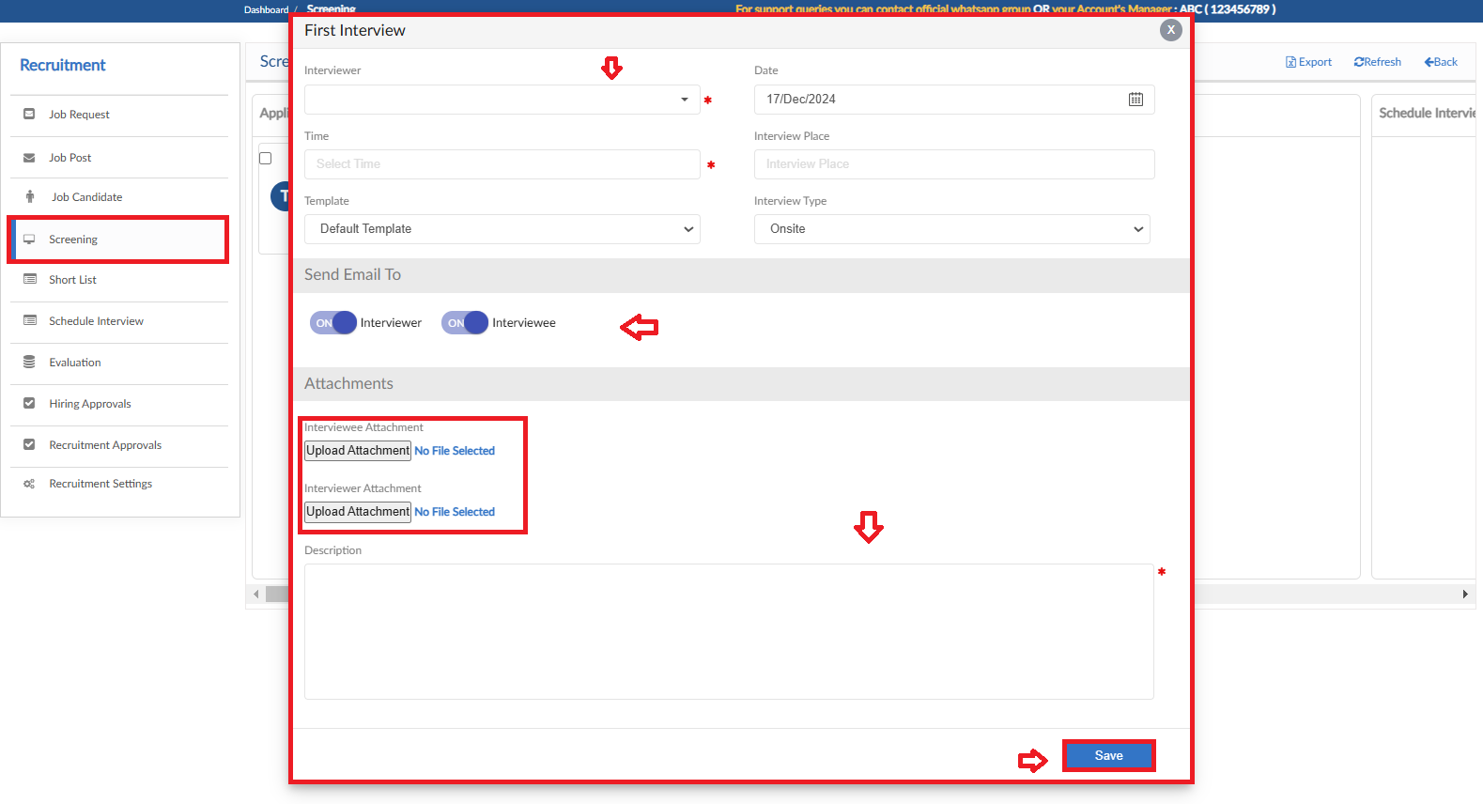

Hiring Approval
- Hiring Approval tile features to send candidates to an employee
- The employee can view the details of candidates and approve or reject

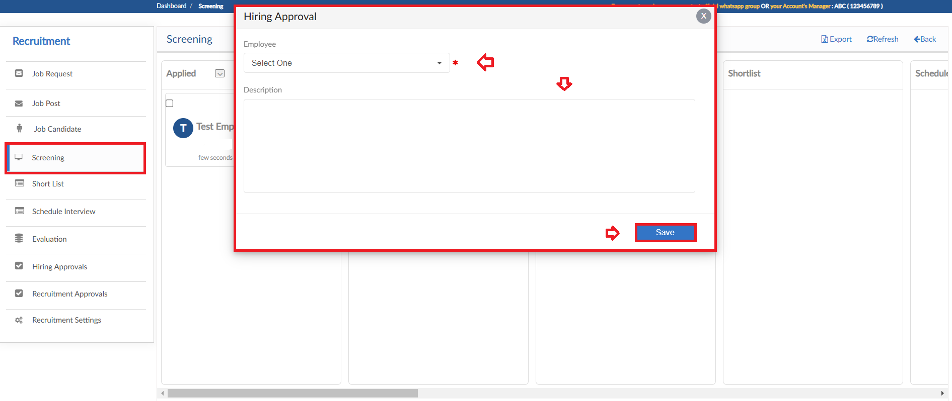

Offer
- Offer tile feature allows to place candidates to show final selection
- If Letter module is enabled then offer can also be placed to candidate

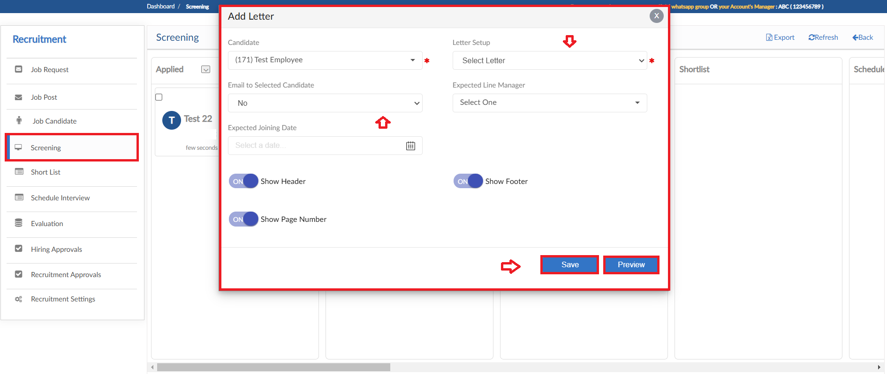

Recruit
- The candidate that have been finalized can be moved to Recruit tile
- Pop up will be visible to select the Station for candidate

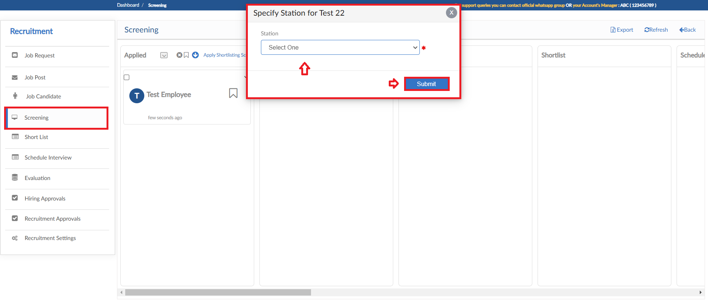

Reject
- Candidates that have been rejected can be placed in Reject tile
- For every candidate comment can be entered

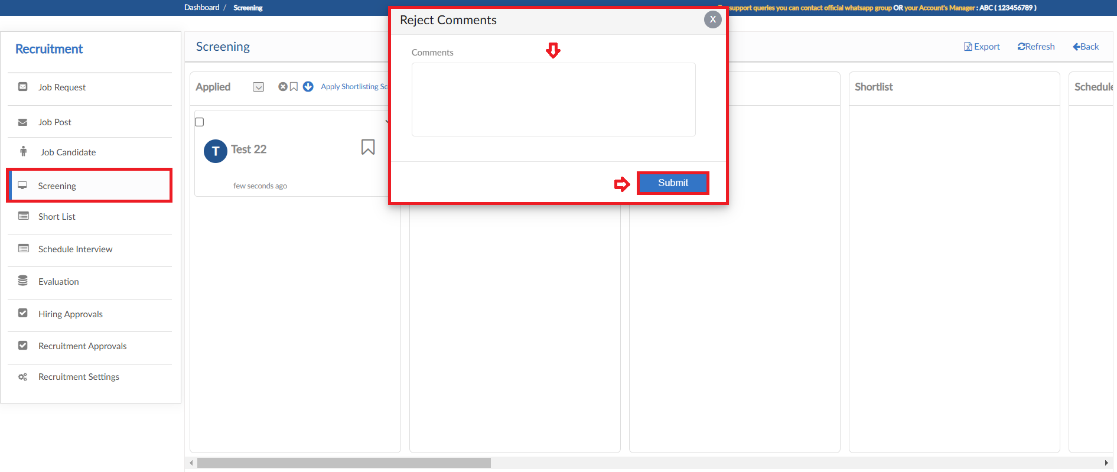

Dropout
- Candidates that have been Dropped from screening process can be placed in Dropout tile
- For every candidate comment can be entered

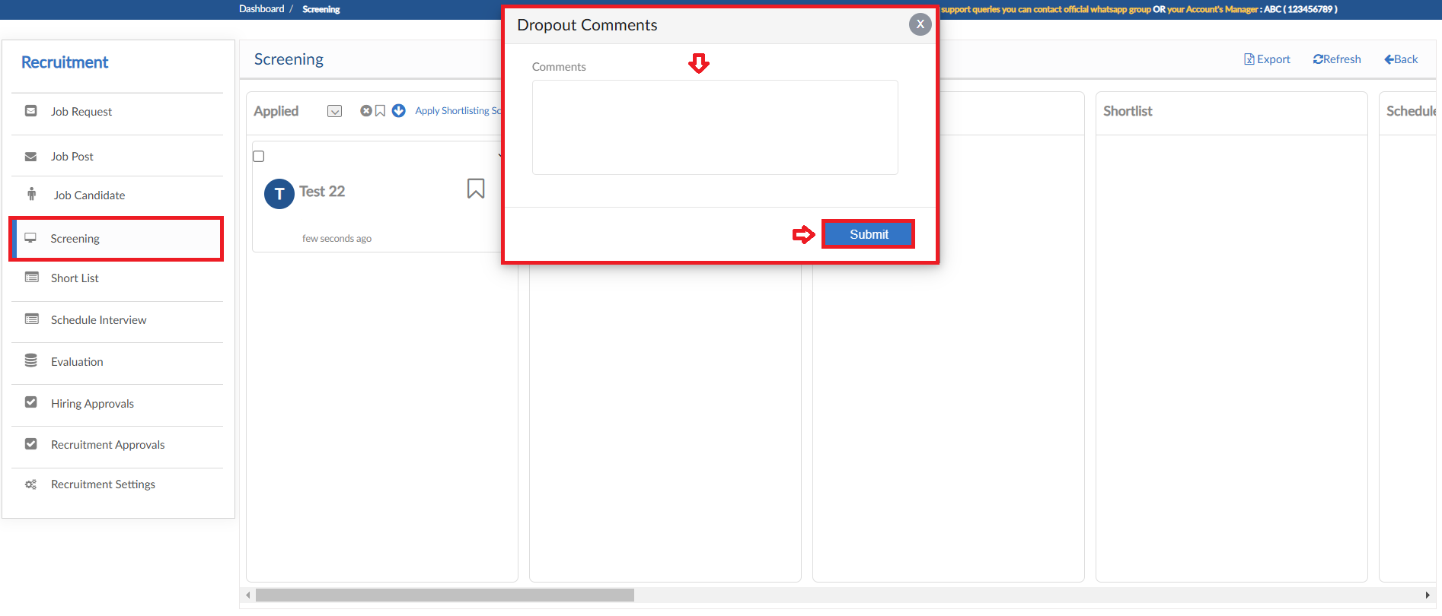

Additional Features
- The screening process provides some additional features for smooth process
- Document Request, Hold & Blacklist Candidate and Notes
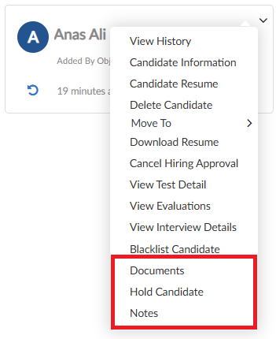
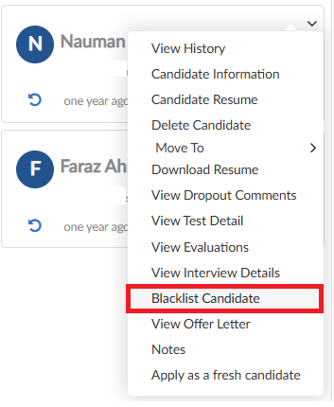

- Document Request
User can request from the candidate during the screening process that will be reflected on the candidate portal and approved/rejected through system once it’s been uploaded

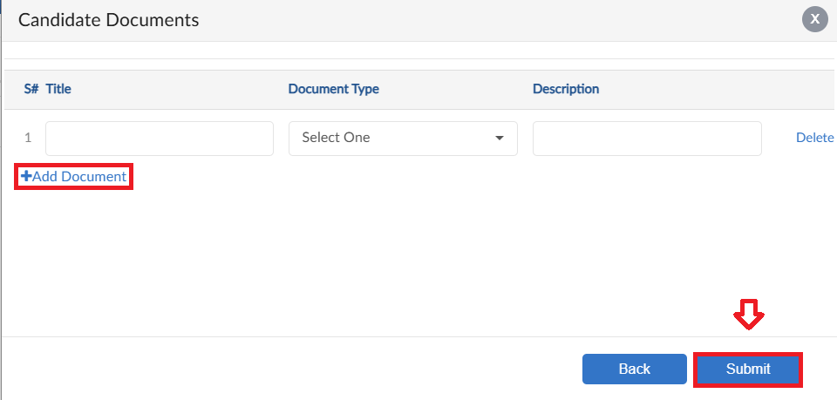

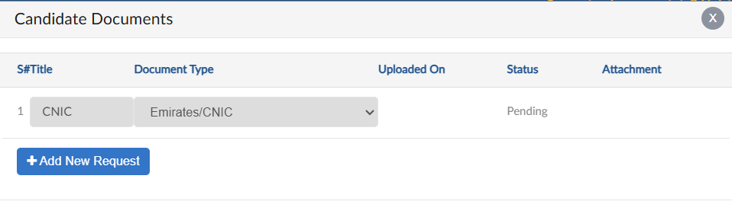

- Hold Candidate
This feature allows user to Hold a candidate in the screening process, the application will now be at a halt state cannot move in any tile or action being performed until the candidate is released
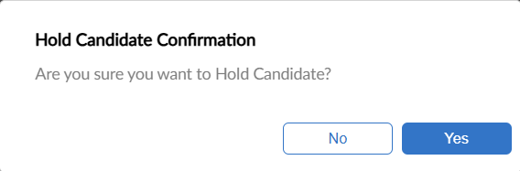
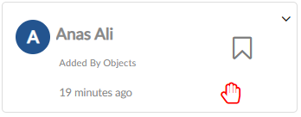
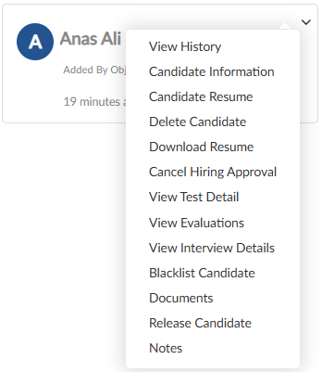

- Notes
User can enter notes/comments against an application for keeping track of screening process. The notes/comments will be shown tile wise

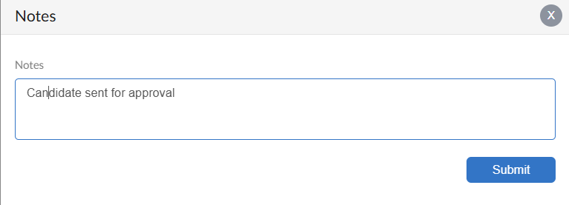
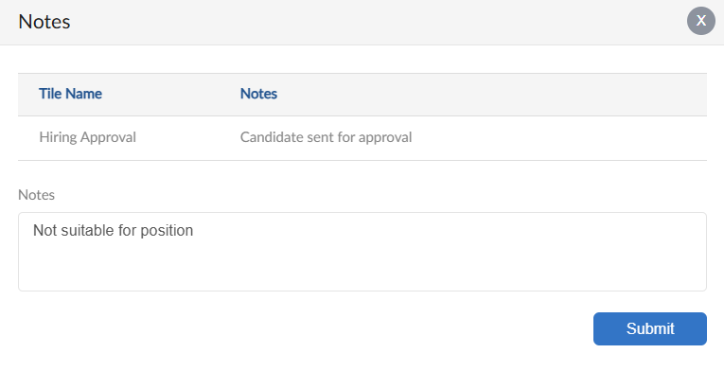

- Blacklist Candidate
The feature allows user to Blacklist a candidate, enter blacklisting reason and submit. The Job card in the tile will be highlighted and can not be moved through tiles.
If the candidate needs to be marked whitelisted can be done through same process

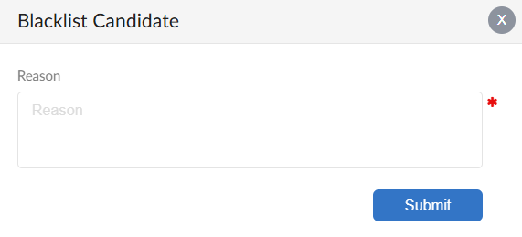

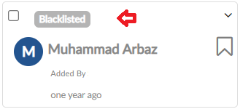

Shortlist

- When candidate placed in Shortlist tile in Screening it will be shown in this form of the selected employee
- Shortlist form grid will show all the candidates and their details
- Click on action button to perform other process

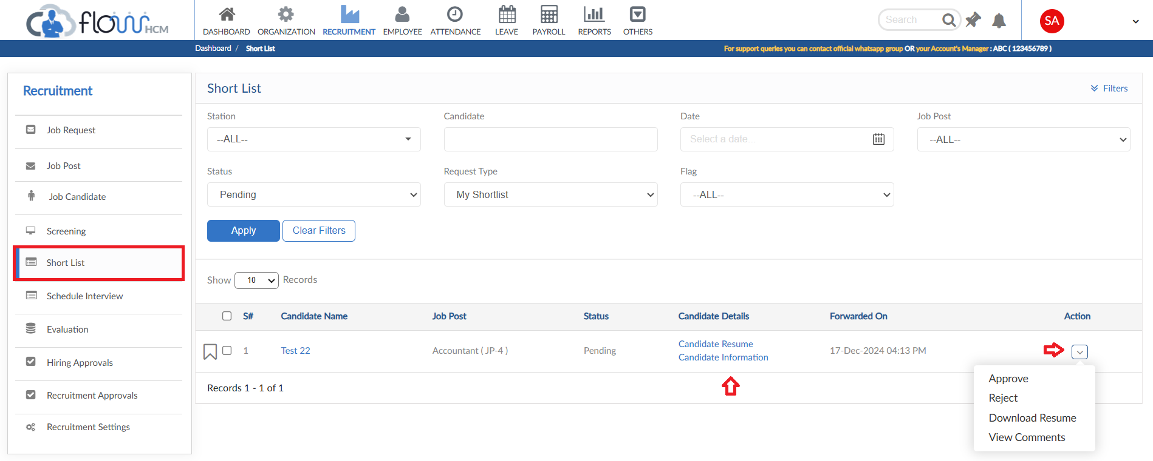

Schedule Interview

- When candidate placed in Schedule Interview tile in Screening it will be shown in this form of the selected employee
- Schedule Interview form grid will show all the candidates and their details
- Click on action button to perform other process

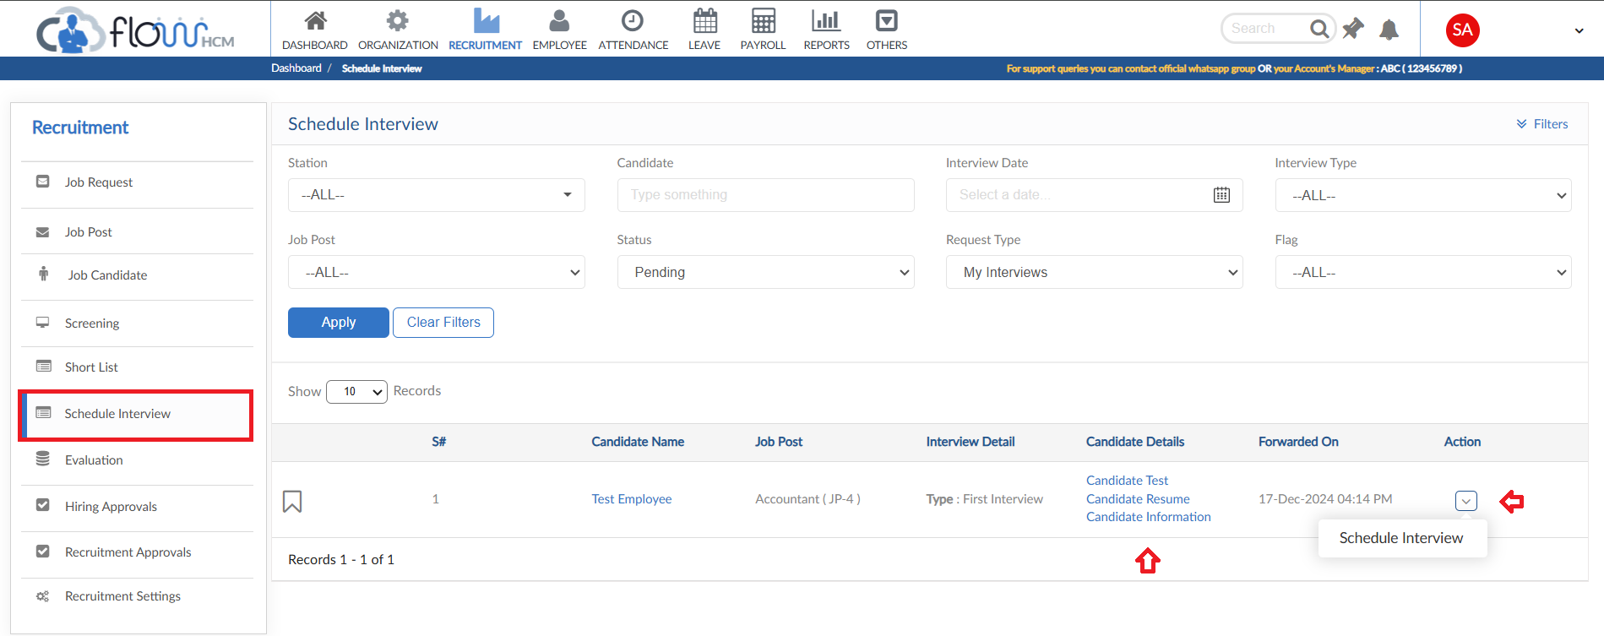

Evaluation

- When candidate placed in Interview(1st 2nd 3rd) tile in Screening it will be shown in this form of the selected employee
- Evaluation form grid will show all the candidates and their details
- Click on Evaluate in action button to score the candidate as per Interview Template

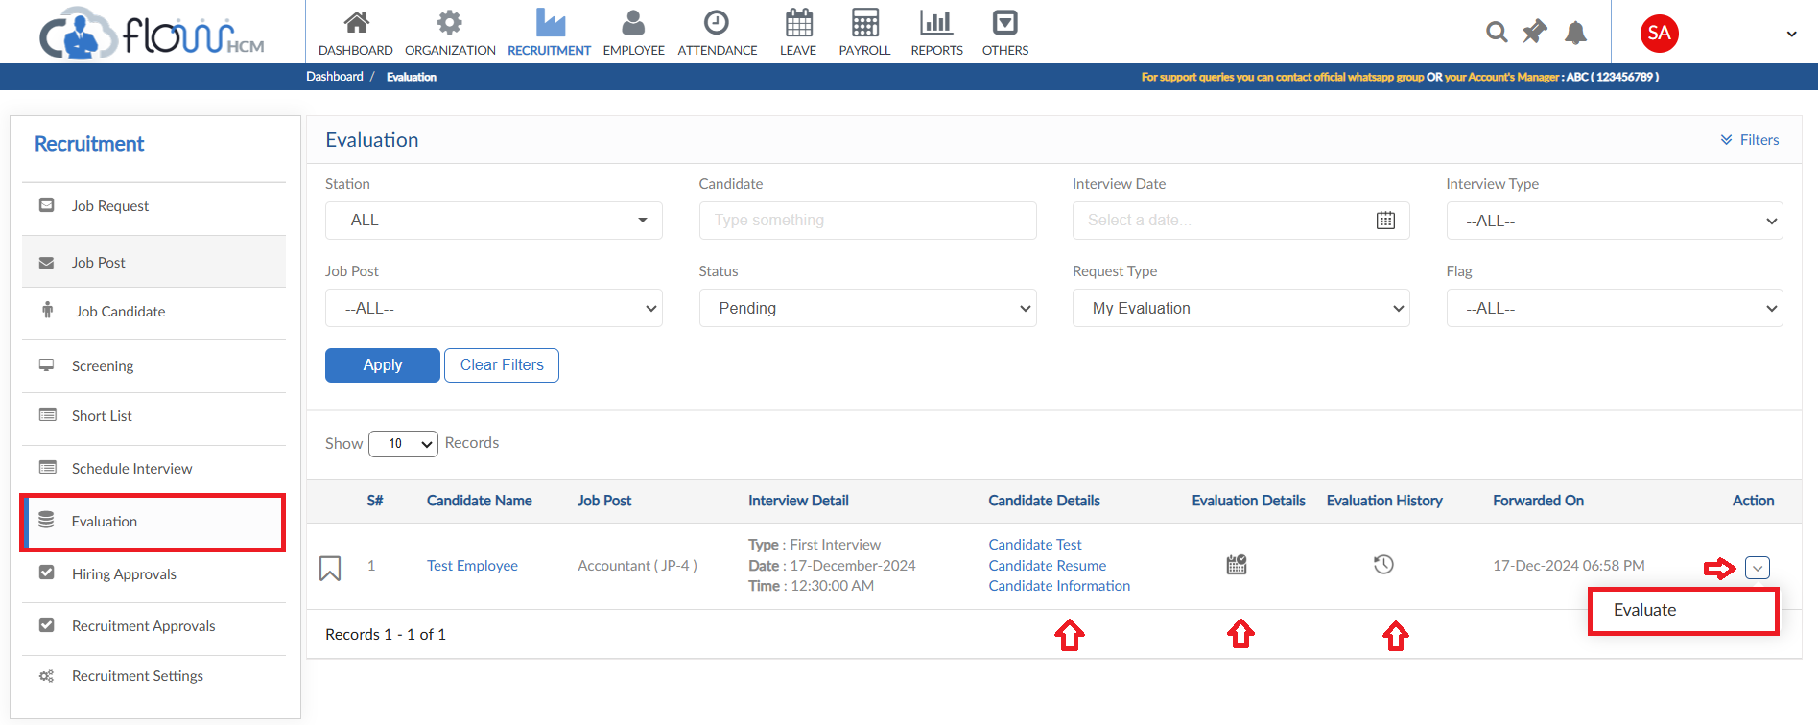
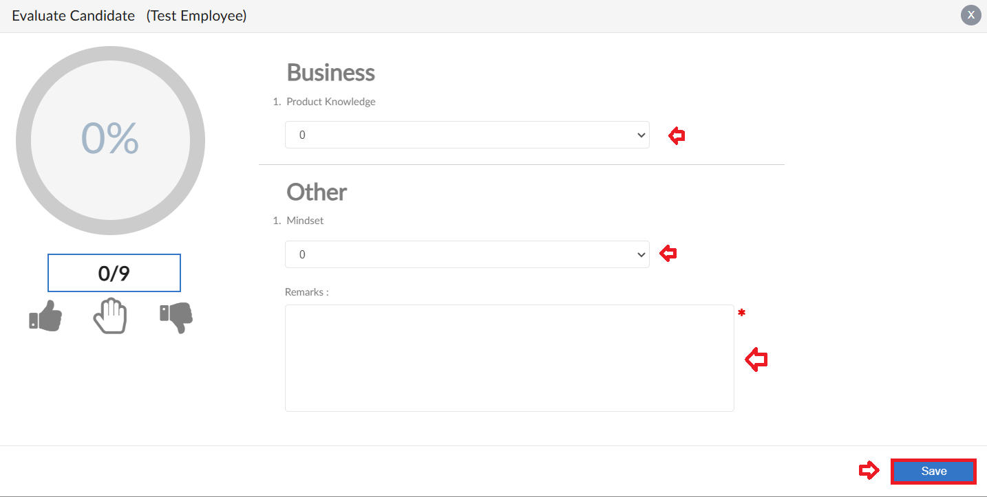

Hiring Approvals

- When candidate placed in Hiring Approval tile in Screening it will be shown in this form of the selected employee
- Hiring Approval form grid will show all the candidates and their details
- Click on action button to perform other process

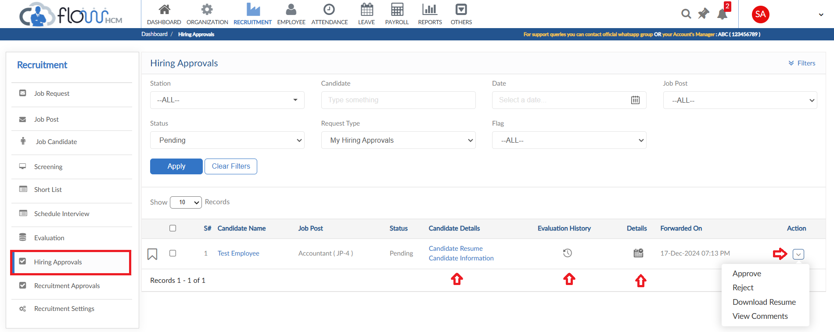

Recruitment Approvals

- All the Job requests and Candidate Document approval will be shown in this form grid
- Details of the Job request and Candidate Document can be seen in the grid
- Click on action button to perform final action

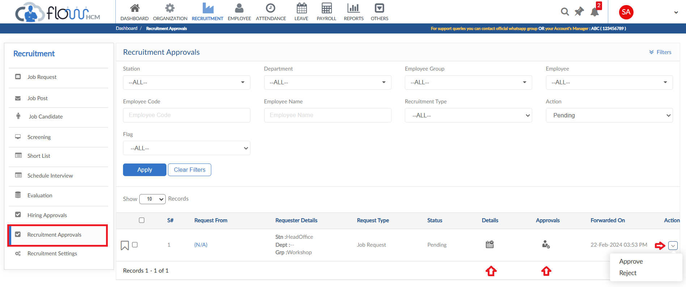

Recruitment Settings

- Employee Setting form consists of multiple setup forms
- Click on Employee Setting form

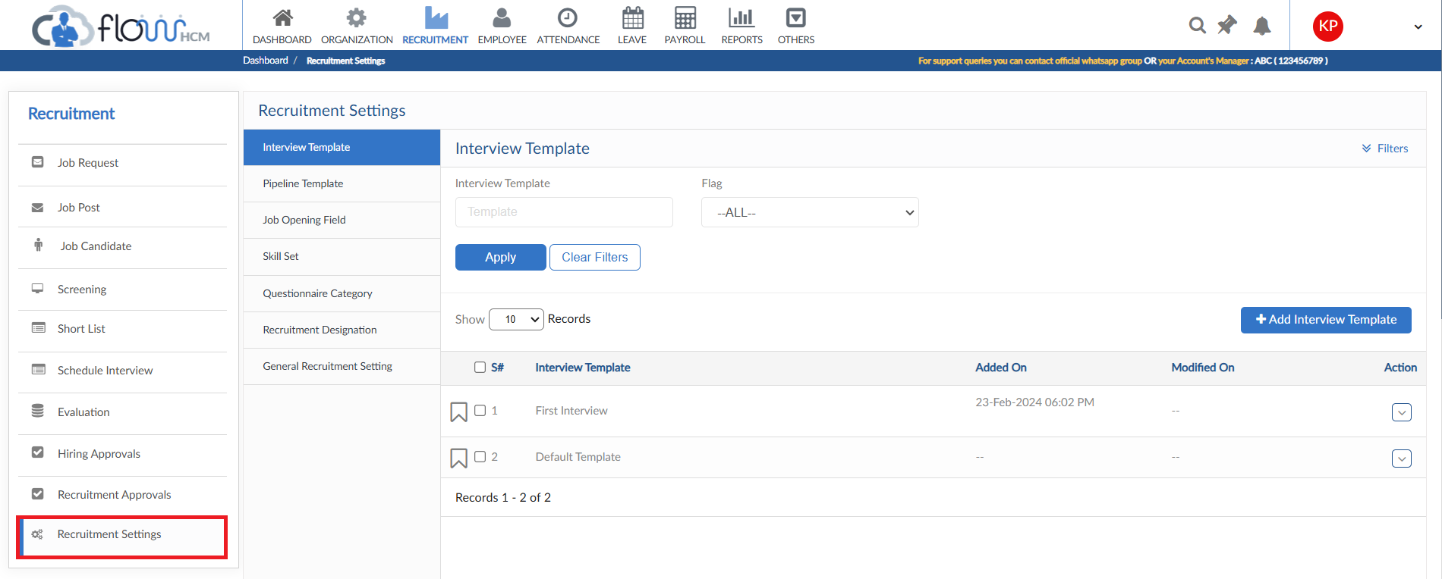

Interview Template
- Click on Add Interview Template
- Create a template that will be used in candidate evaluation

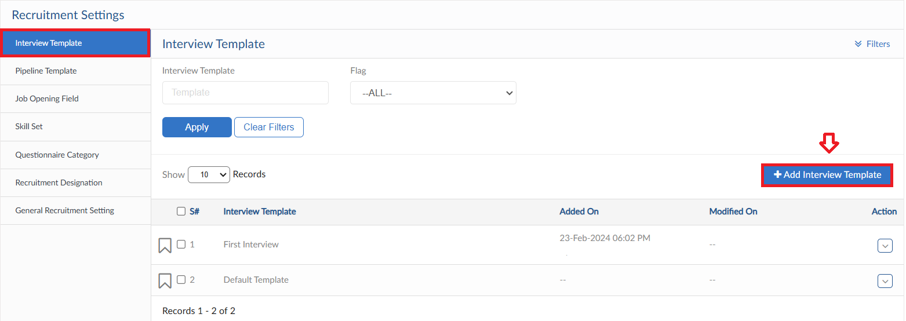
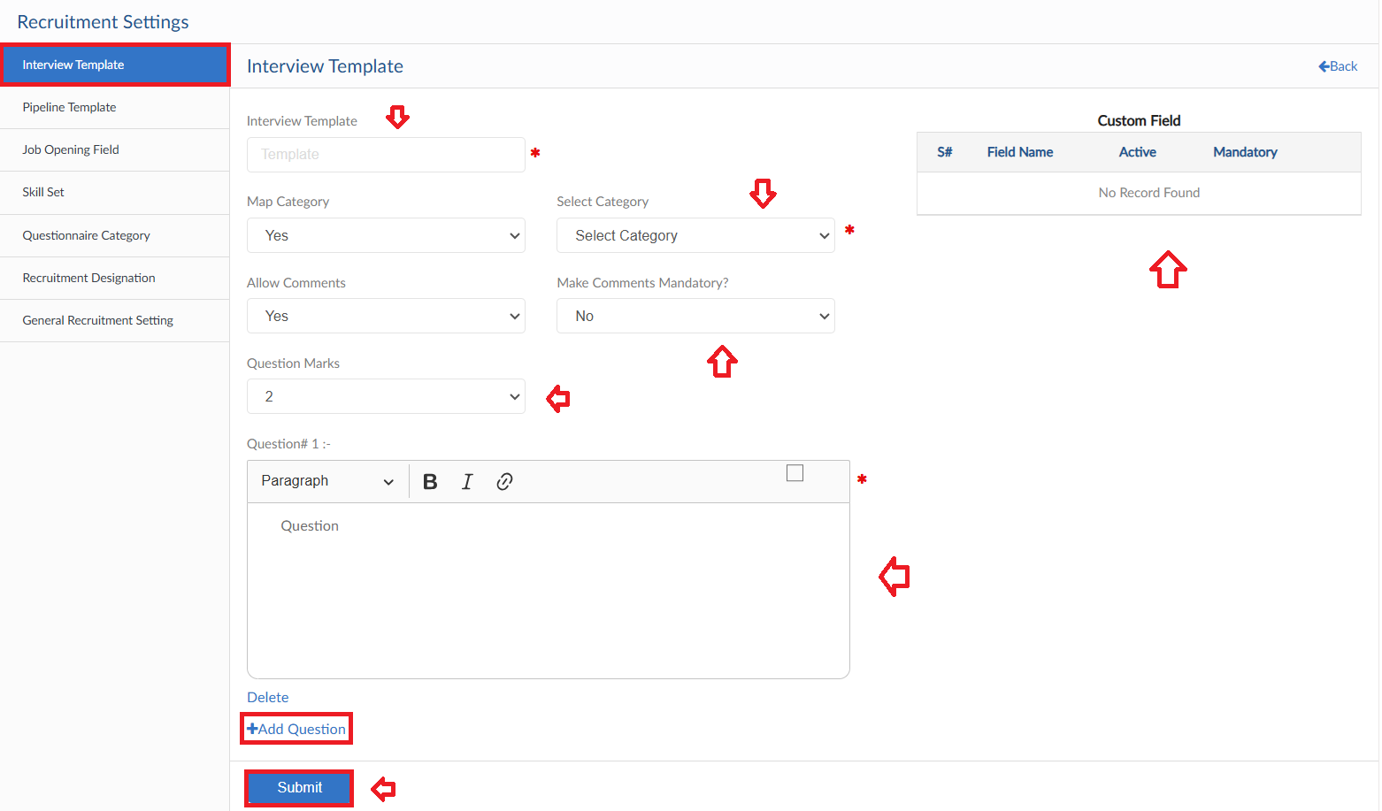

Pipeline Template
- Pipeline Template is used in screening process
- All tiles can be customized as per requirement
- Addition or Deletion of tile in Pipeline and notification to any specific employee on transaction
- Additionally, some tile has a feature to send email to the candidate as well
- User can create a custom Pipeline, click on Create New Pipeline

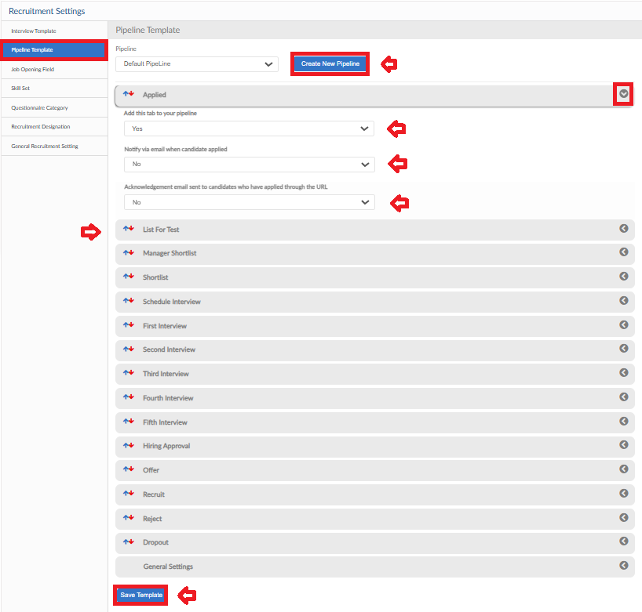
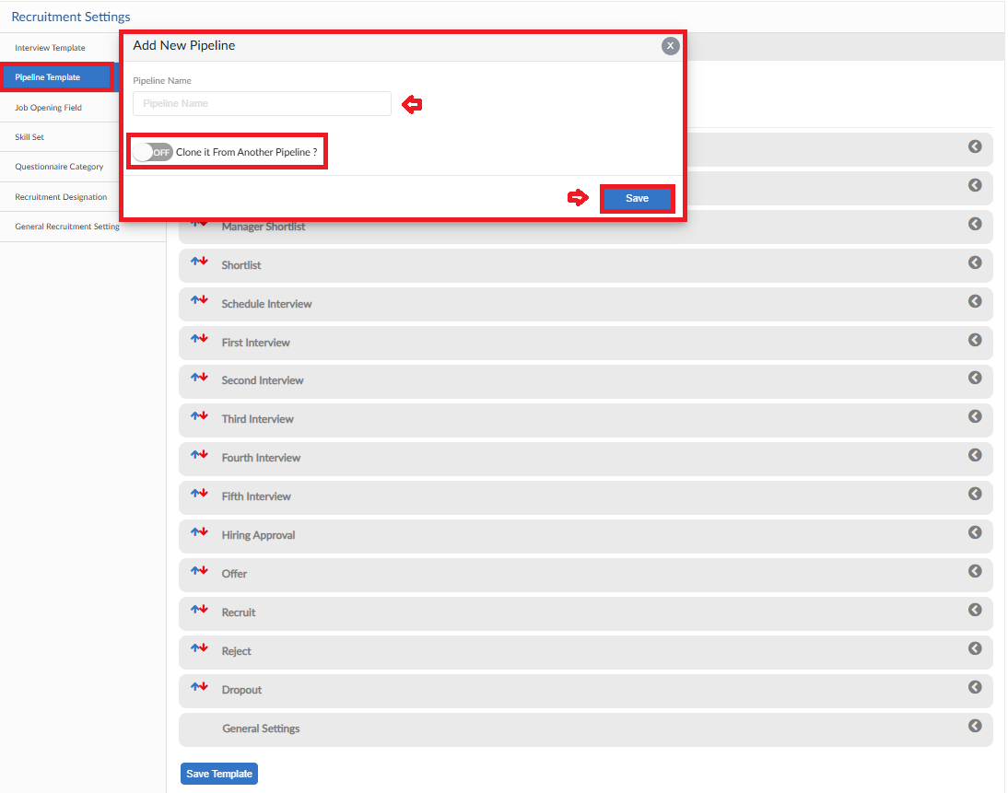

Job Opening Field
- Job Opening field consists of all the fields that will be shown in Application form through Job & Candidate Portal to be filled
- These can be custom as well for different Job Posts
- Fields settings for Guest and Candidate are defined individually
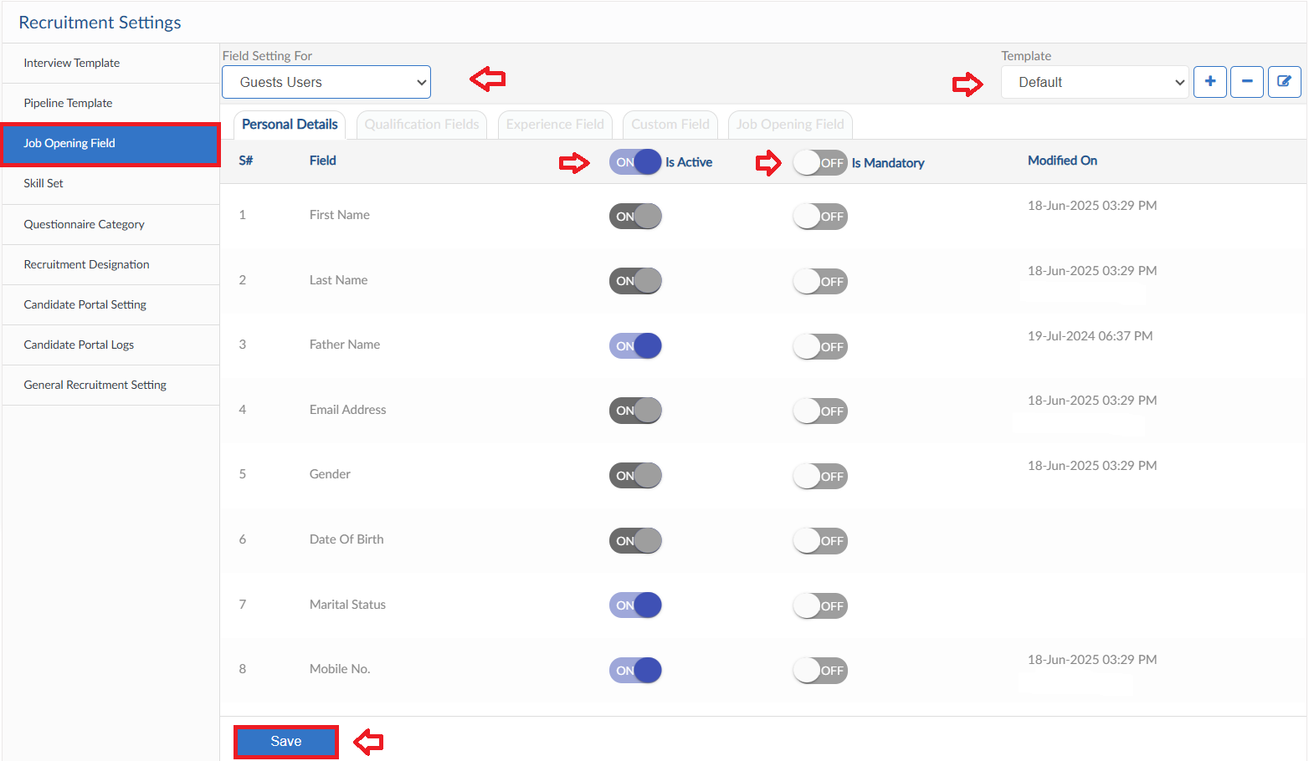
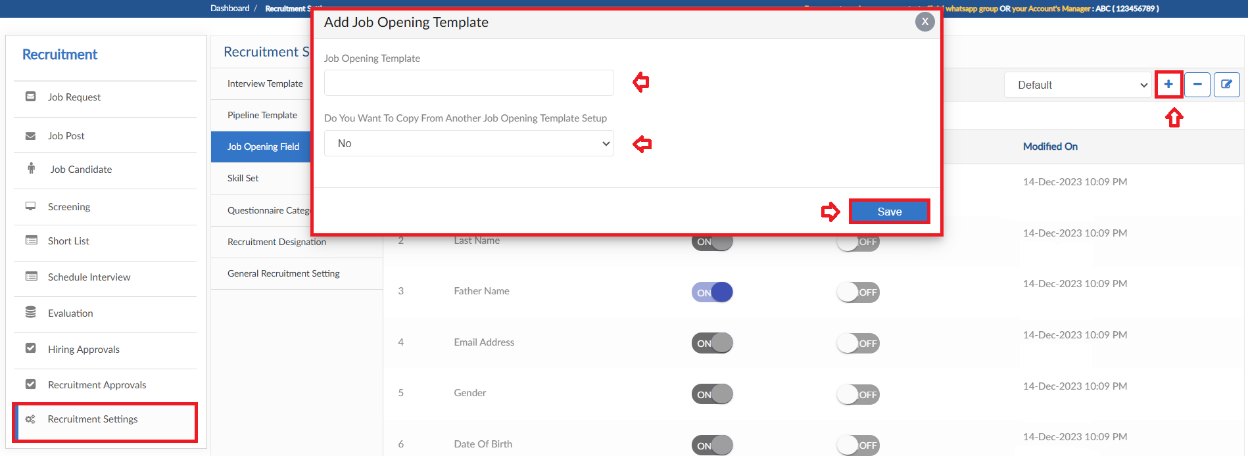
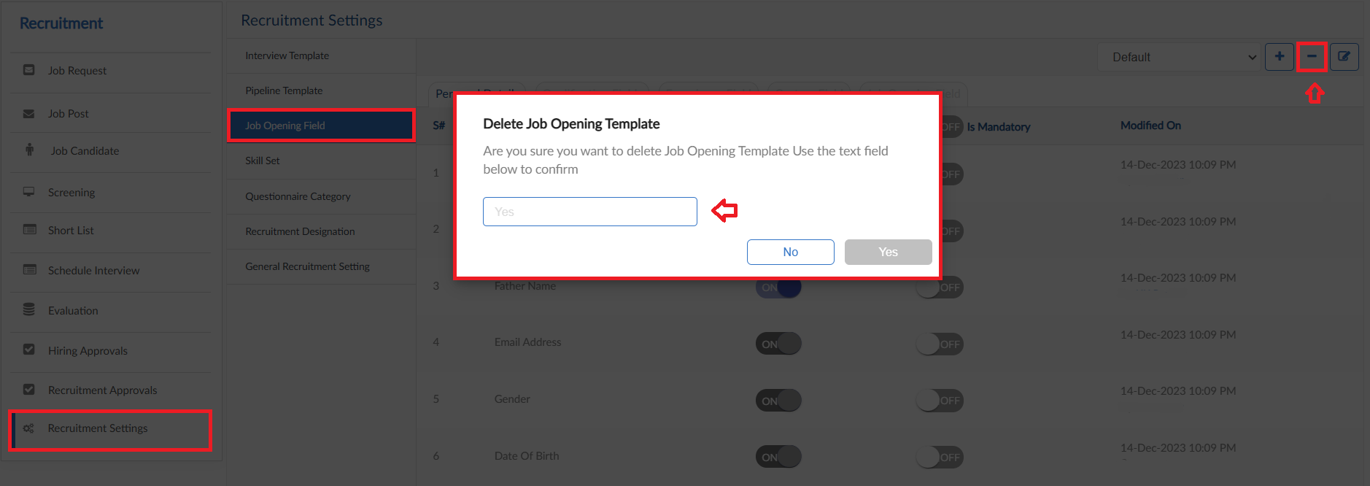
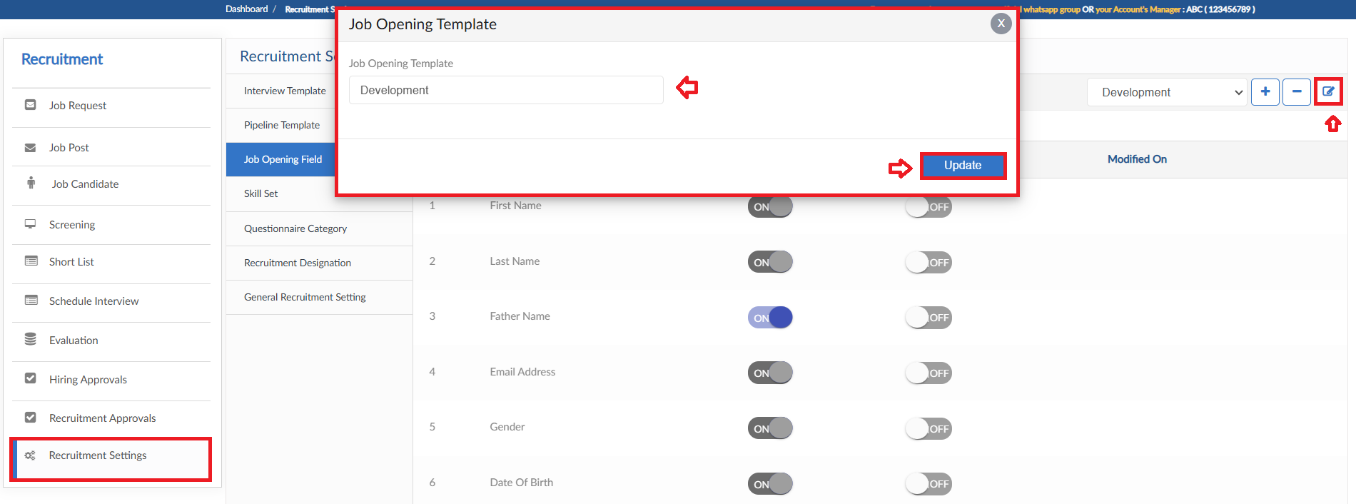
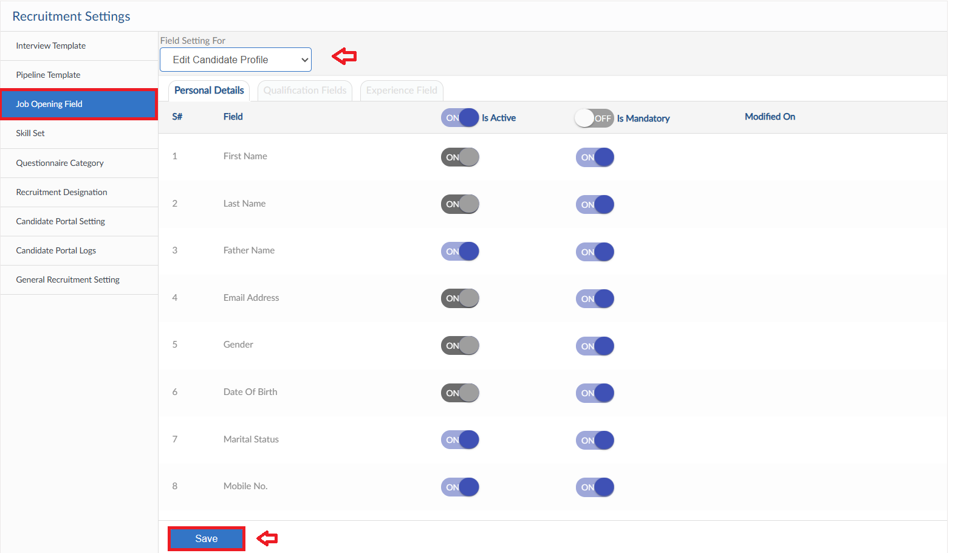

Skill Set
- This form is a library for skill sets
- Click on Add Skill Set, pop up will be visible
- Enter Tile and click Save button

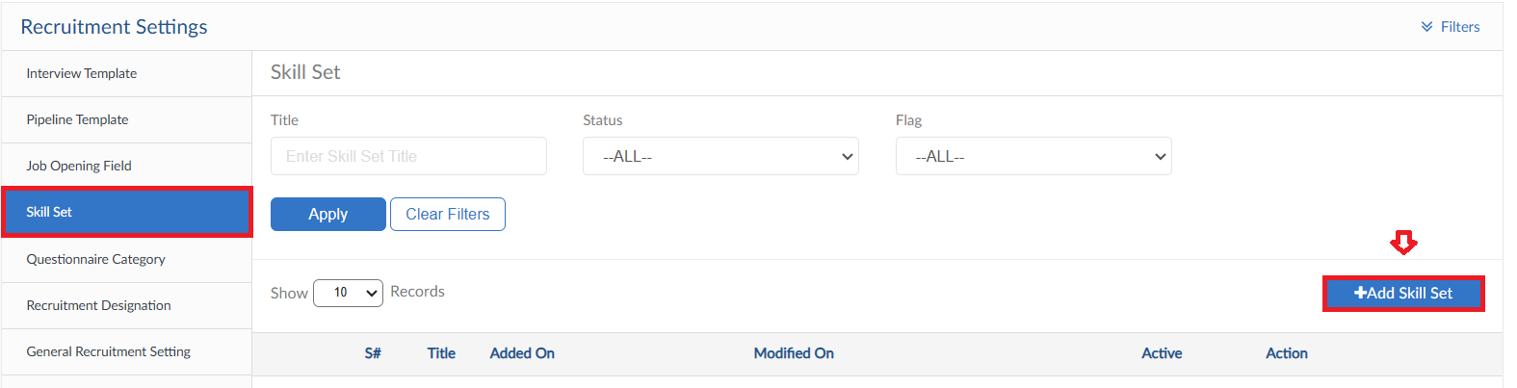
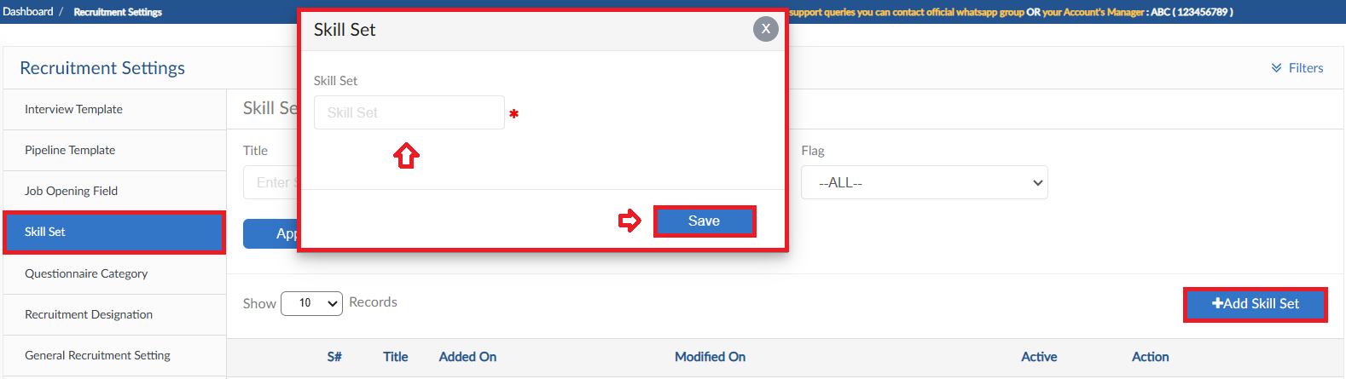

Questionnaire Category
- This form is a library for categories of Interview Template questions
- Click on Add Category, pop up will be visible
- Enter Tile and click Save button

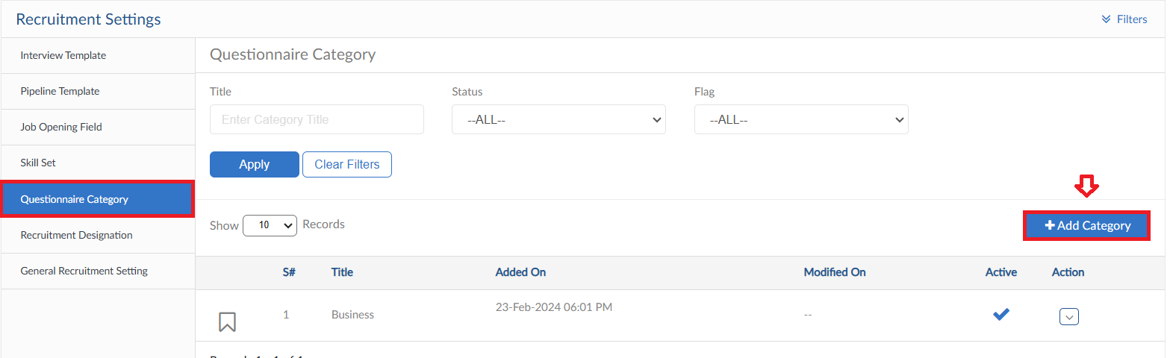
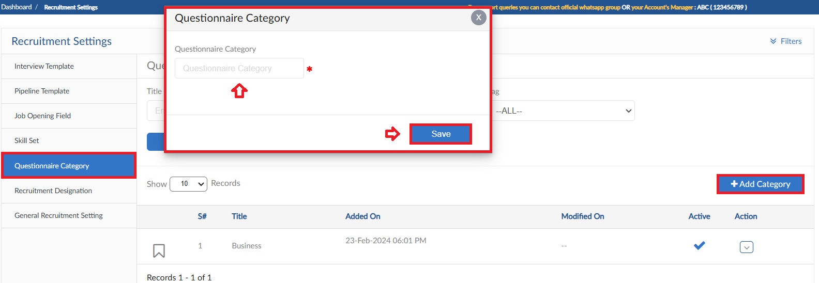

Recruitment Designation
- This form is a library for Designations used in Recruitment Module
- Click on Add New Recruitment Category, pop up will be visible
- Enter Tile and code, click Save button

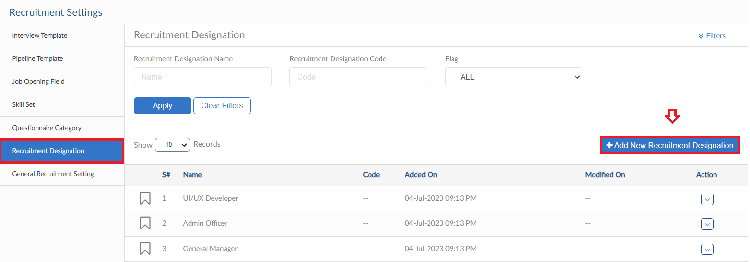
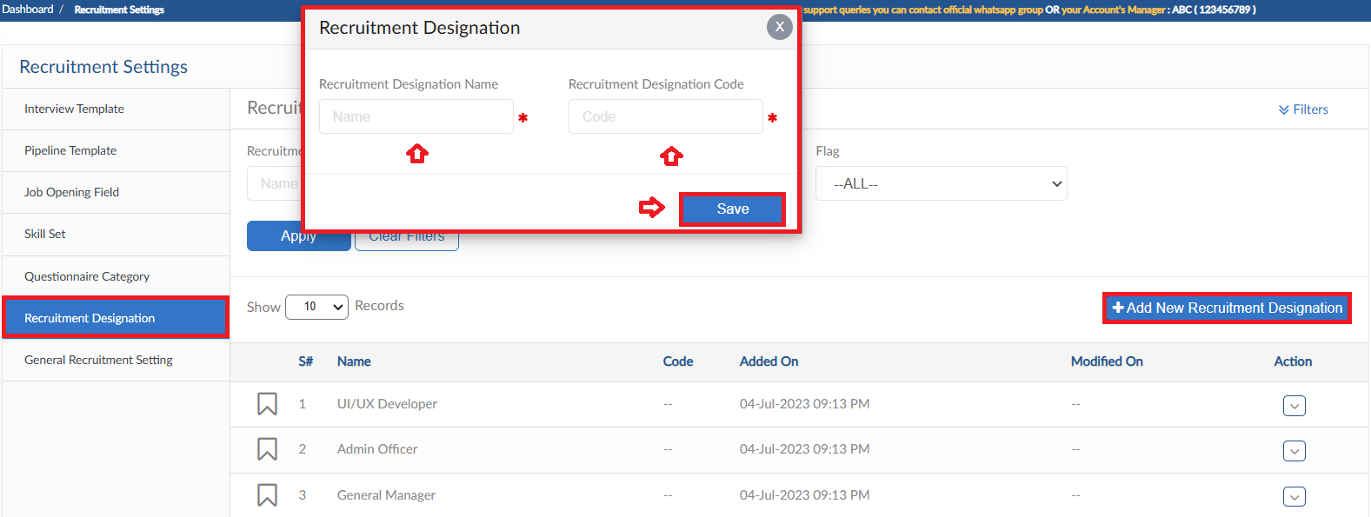

Candidate Portal Settings
- In this form settings and validation for Candidate Portal will be defined
- Define number of months for candidate to re-apply for a position
- Either candidate can apply as guest or not
- Allow candidate to re-schedule an Interview
- Organization Vision/Goals to be shown on Candidate Portal Dashboard
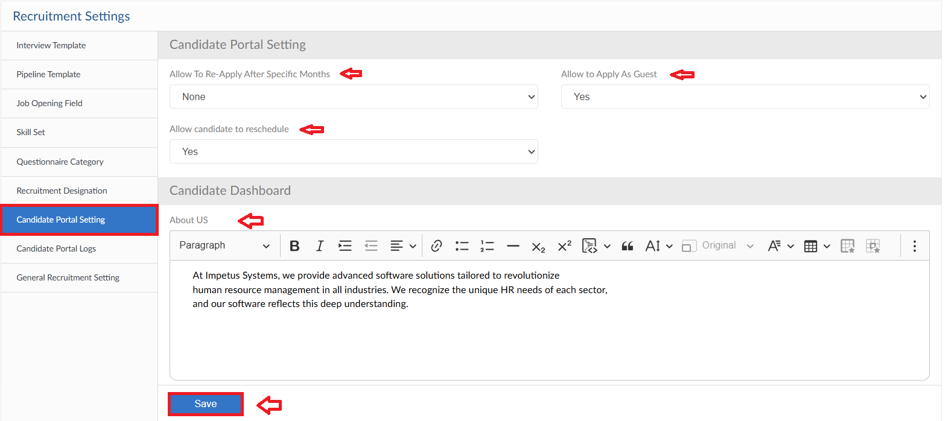

Candidate Portal Logs
- The forms shows the logs against candidates from Portal
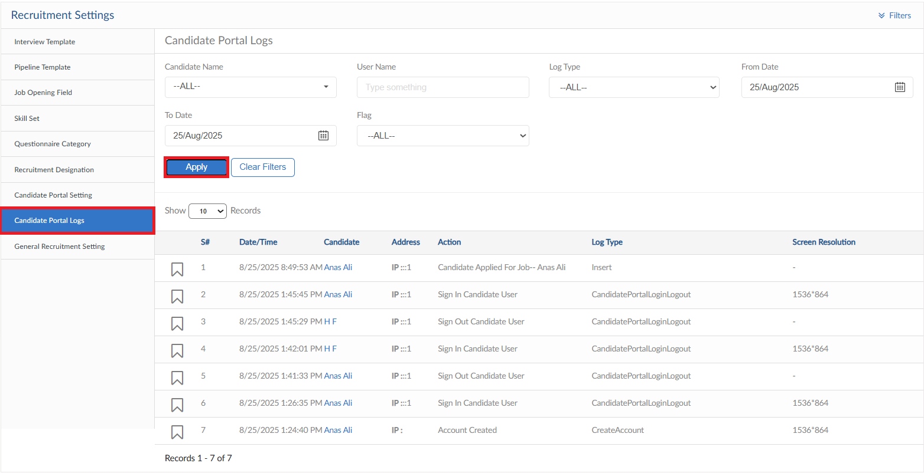

General Recruitment Setting
- In this form approval hierarchy of Job request can be managed

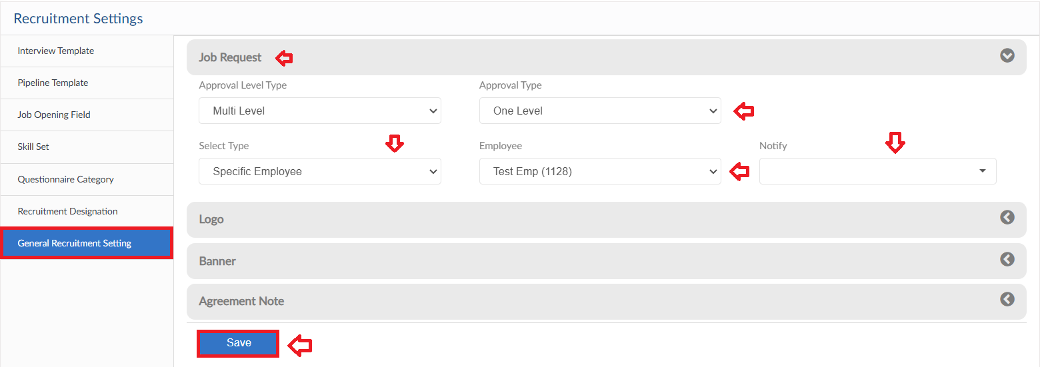

Logo
- Logo required on Job Portal can be uploaded in this form

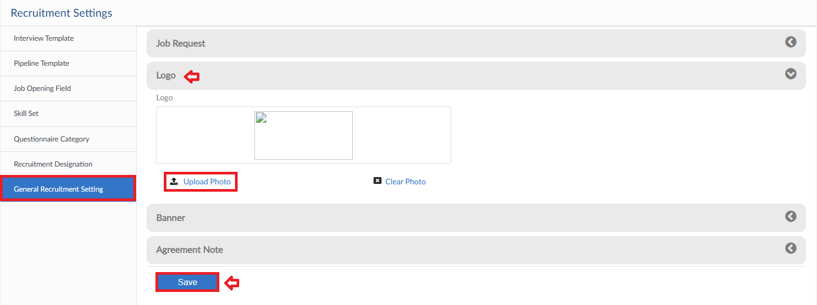

Banner
- Banner required on Job Portal can be uploaded in this form
- The image can be zoom IN/OUT accordingly, height dimension can be defined as well
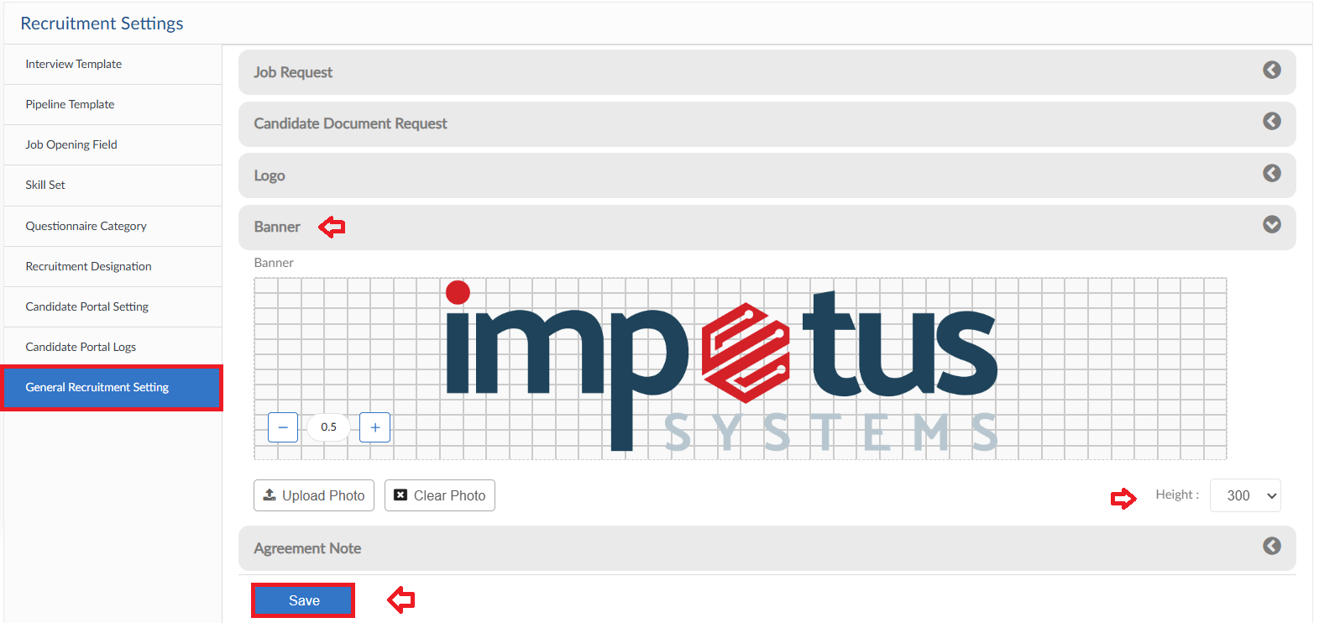

Agreement Note
- Agreement Note on Job Portal for candidate before submitting the application can be managed in this form
- Either a default Note can be selected or user can create a custom note

